Cartography Workshop - US Earthquakes

Go to<http://bit.ly/giscart> and download the **GIScartography** folder from the **Downloads** page. Unzip the folder to your desktop.

Double click the **earthquakes.qgs** to open the lab in QGIS 3.10.

The terrible, horrible, no good, very bad map.

Most GIS made maps suffer from a core set of basic issues: oversaturated colors, poor symbology, distracting backgrounds, bad map projections, too much detail, and crowded data. Taking just a few extra minutes to look for these and other issues before wrapping up a map project can make a big difference in the appearance (and function) of your map.

Our map exhibits serval of these core issues and as a result isn’t doing its best to represent our data. We’ll adjust our map to improve how well it functions.

Visual Hierarchy.

All images have 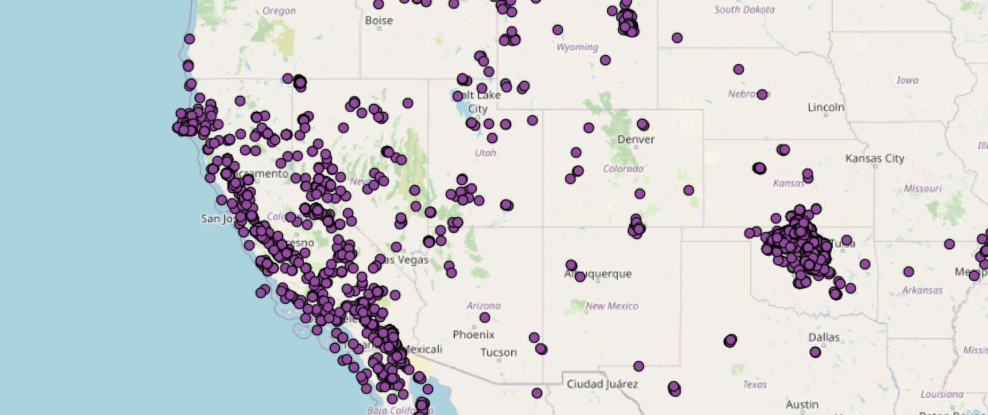a visual order, from background to foreground, this is the **visual hierarchy**. Our style choices affect where each feature or layer sits in our maps visual hierarchy. More important map features should sit at the top of the VH, while less important or contextual features should recede to the back. Visual hierarchy is based on an Intellectual Hierarchy, or an understanding of what information is most important in our map.

In our current map, the saturation of colors and detail of the default basemap are conflicting with the point symbols for our data. Making them less obvious as the focal point of this map.

Changing the points to a brighter color can make them easier to see, but that’s a slippery slope towards overly saturated or bright symbology that competes with the rest of our data.

Open to the **Web** **>** **QuickMapServices >** **CartoDB** menu.

Select **Positron** basemap.

Uncheck the **OSM Standard** basemap.

Simply switching away from a full color detailed basemap to a grayscale map adds a lot more space in the visual hierarchy between the point symbols and the background, elevating our data in the VH. A side benefit of a grayscale background is that it frees up more color space for you to apply to the data itself, more colors become available to represent data.

But, our symbols for earth quakes and cities are still too similar to differenti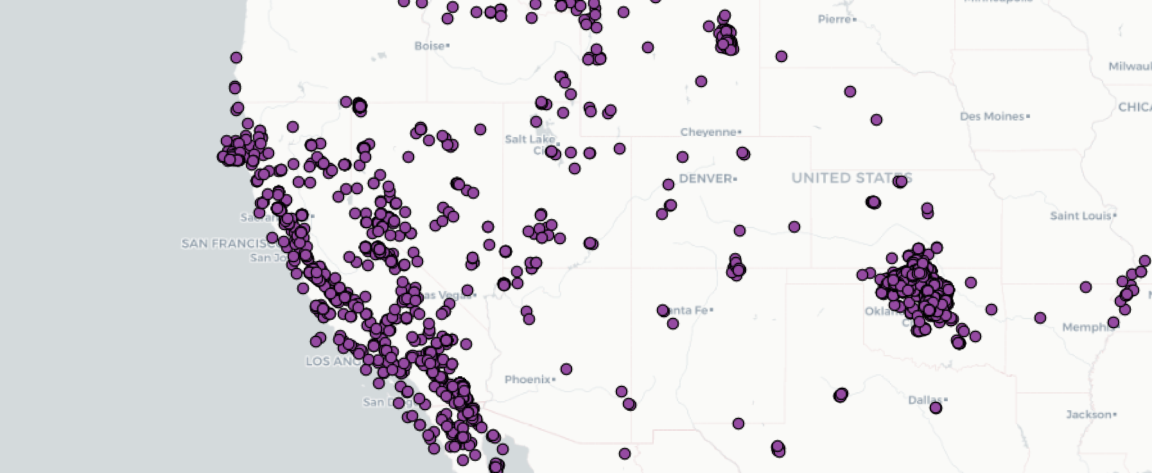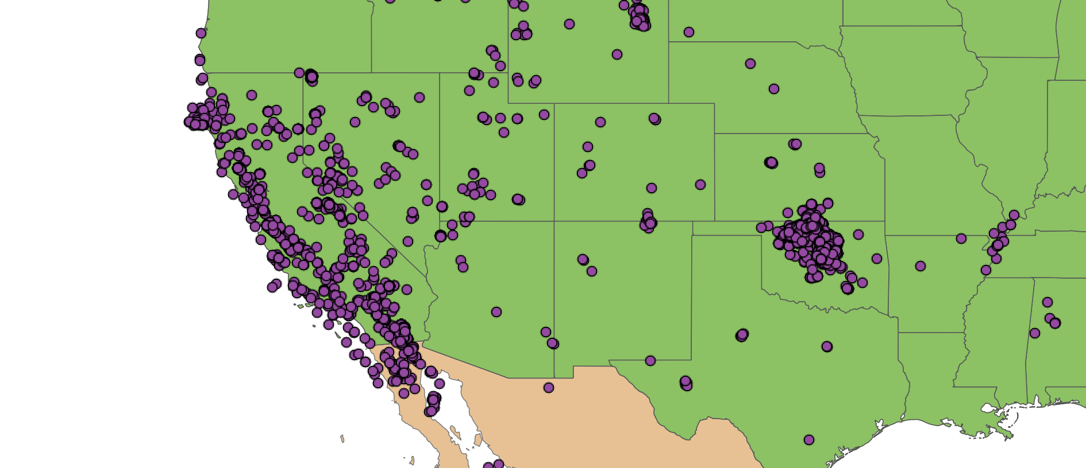ate. We can pull the cities away from the data layer by changing its style to better match the background map.

This is a good start, but we can almost certainly do better! Repeat after me… “I can do better than default”! Instead of relying on a pre built basemap, let's build our own.

Right click on both basemap layers and select **Remove Layer…**

Check the box next to the **US_states_10m** layer to make it visible.

Check the box next to the **Countries_10m** layer to make it visible.

PS notice how the VH compresses again once we add color back to the map!

Double click the **US_states_10m** layer to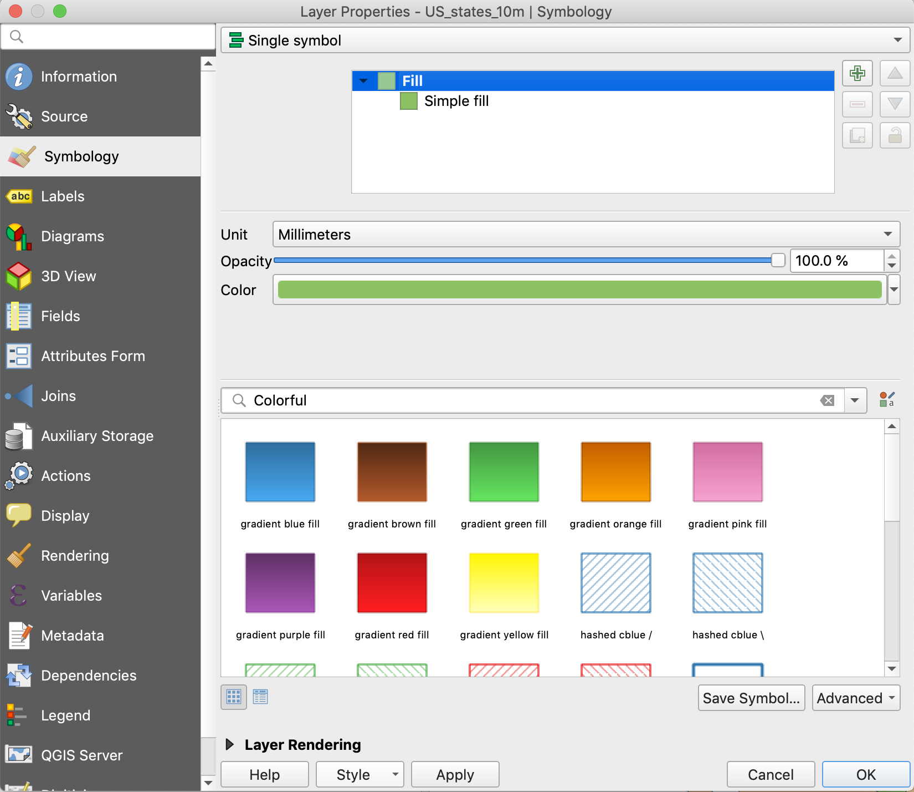 open the **Layer** **Properties** window and go to the **Symbology** menu.

From here we can control how our symbols will appear in the map. Change their fill and outline colors; change line thickness; classify symbols by their attributes; or apply other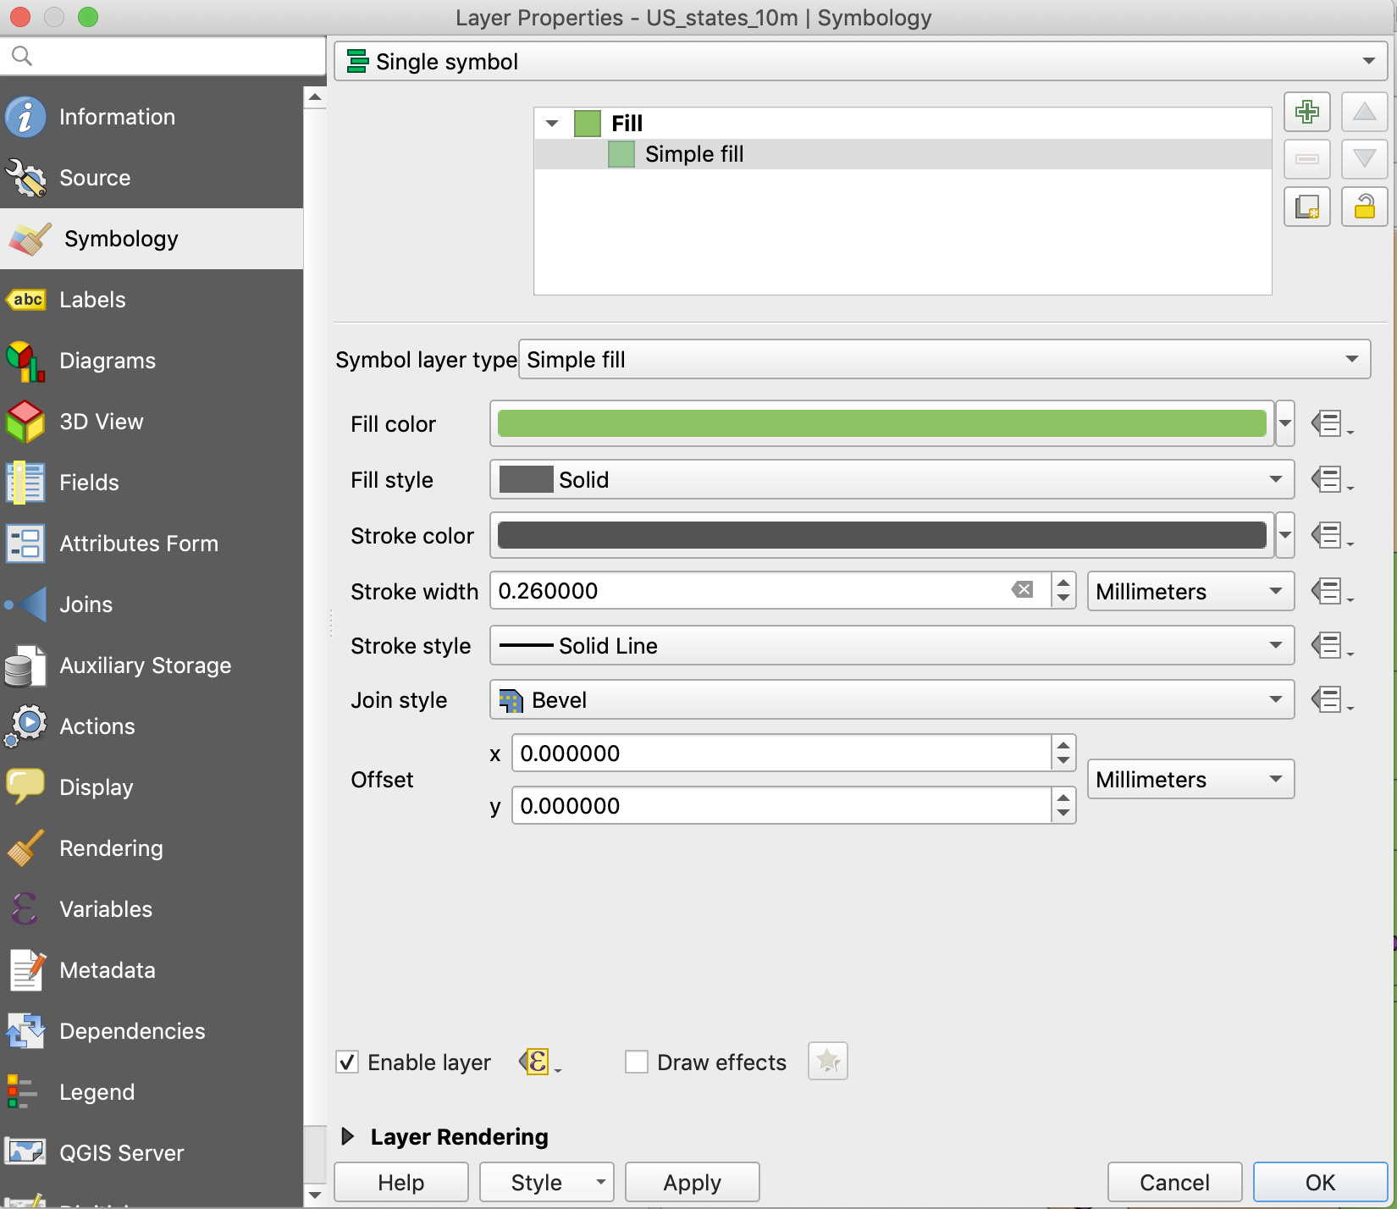 more advanced effects. For now let's just change our base fill and outline colors.

Leave the symbol type set to **Single Symbol**.

Select **Simple fill** from the top window (this changes the lower contextual menu).

Quick detour: if you select the Symbol layer type drop down you’ll see a whole list of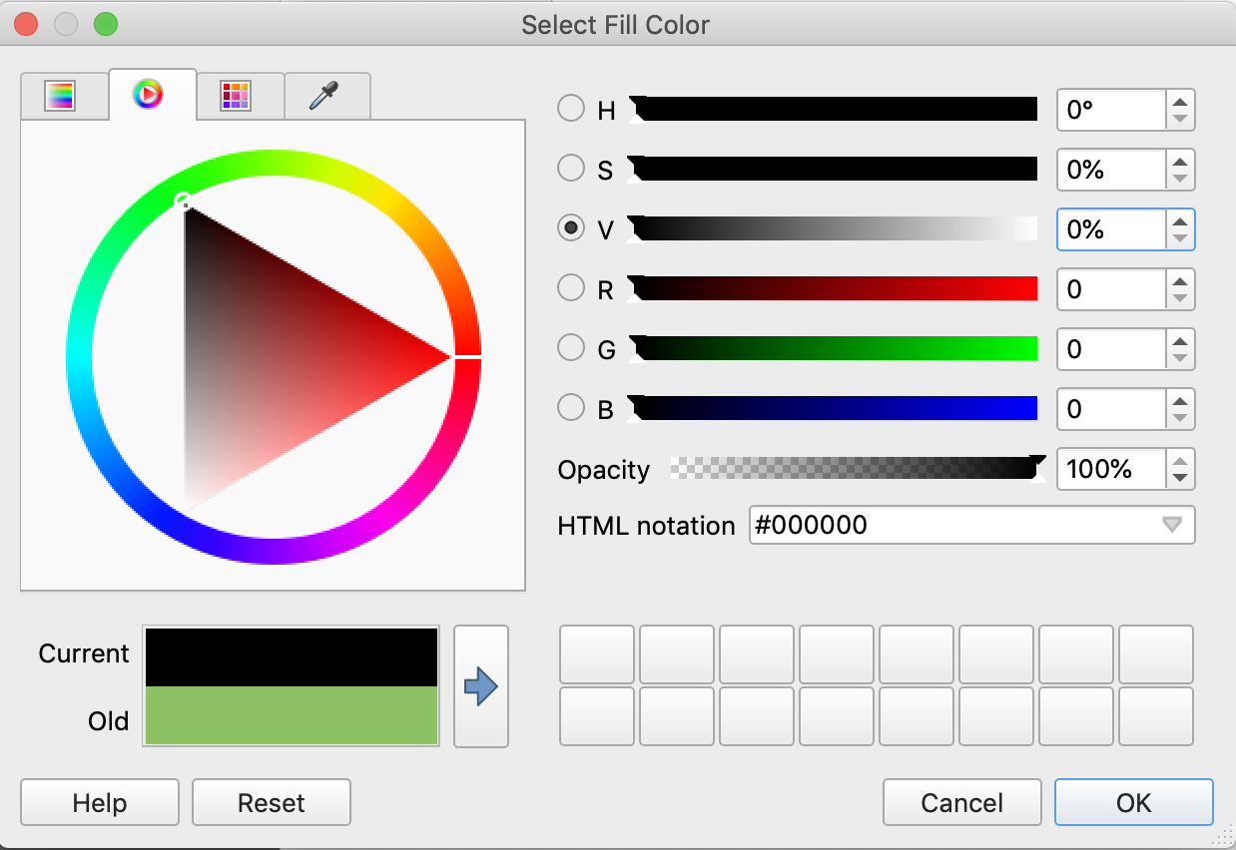 interesting options for changing the way the State polygons can be symbolized. For now we’ll stick with Simple fill, but feel free to come back here later and play around.

Click on the color bar next to **Fill color.**

Set the **H S** and **V** slider values to 0 (this sets the Current color to full black).

Now start moving the **V** slider to the right and notice that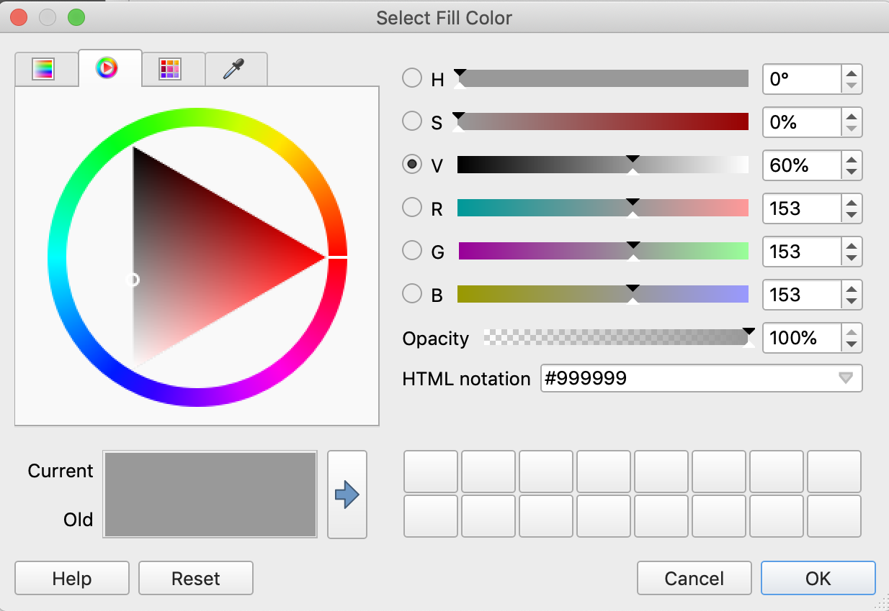 the Current color is changing to various shades of gray.

Click in the **V** value field and enter **60%** (which creates a 40% gray), click OK.

Now click on the bar for **Stroke color.**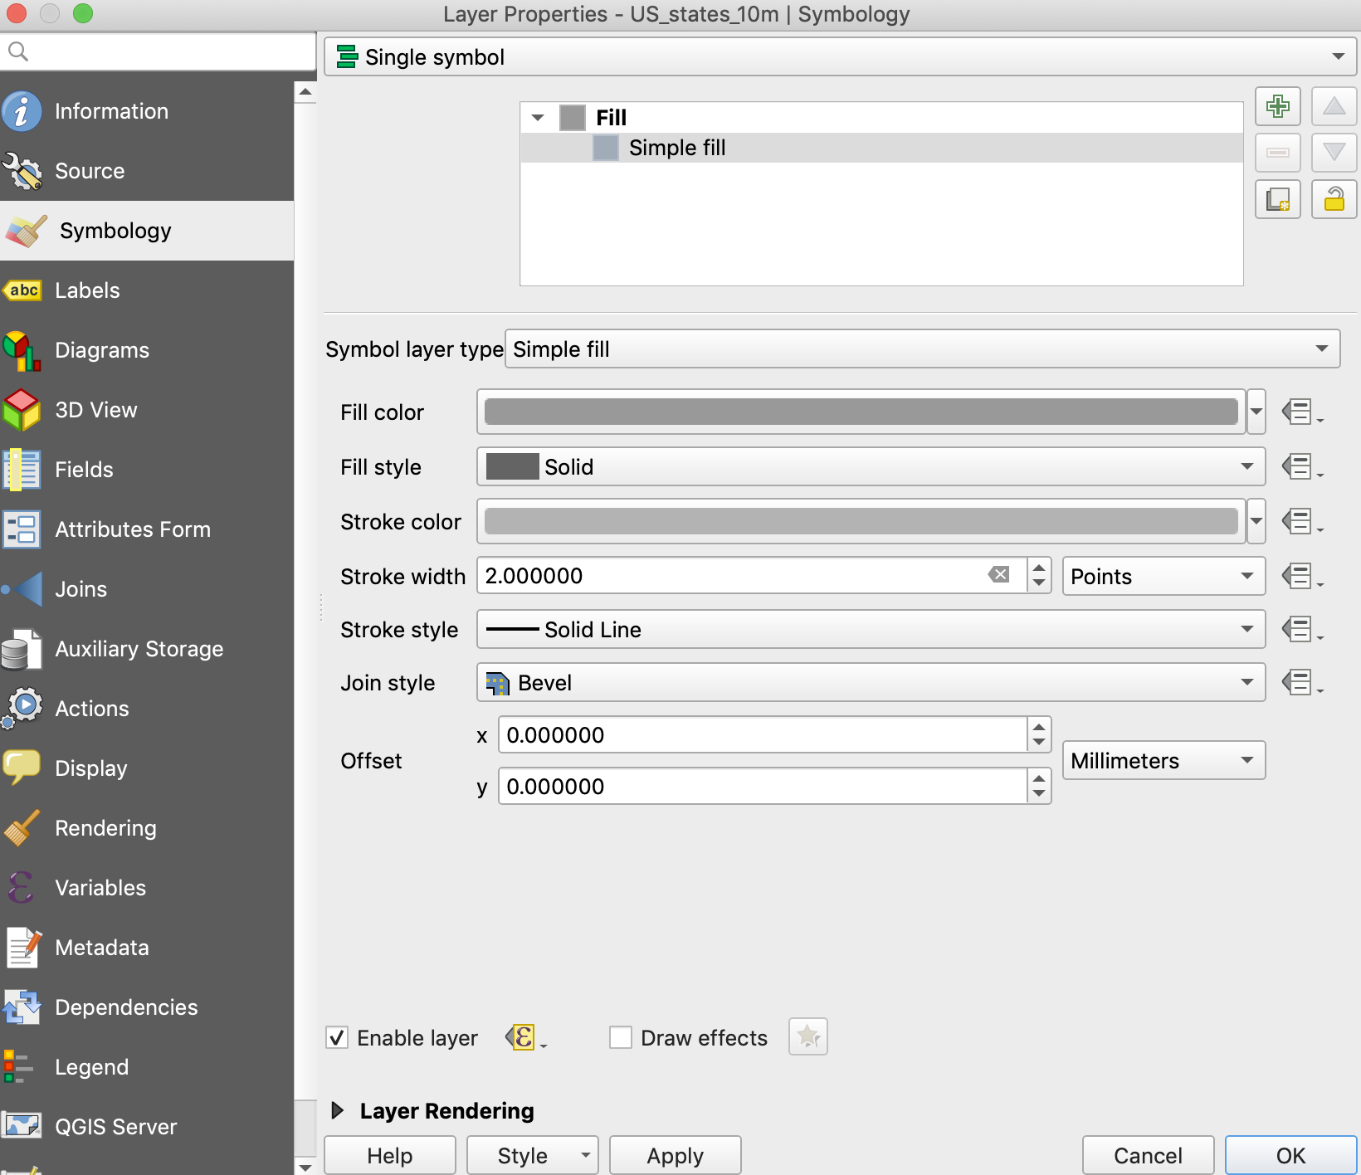

Set the **HSV** sliders to0 0 and **70%** (for a 30% gray outline color), click **OK**.

Next to **Stroke width** enter **2** and change the units to **Points**.

Click **OK** to apply all your changes.

Now double click **Countries_10m** and go to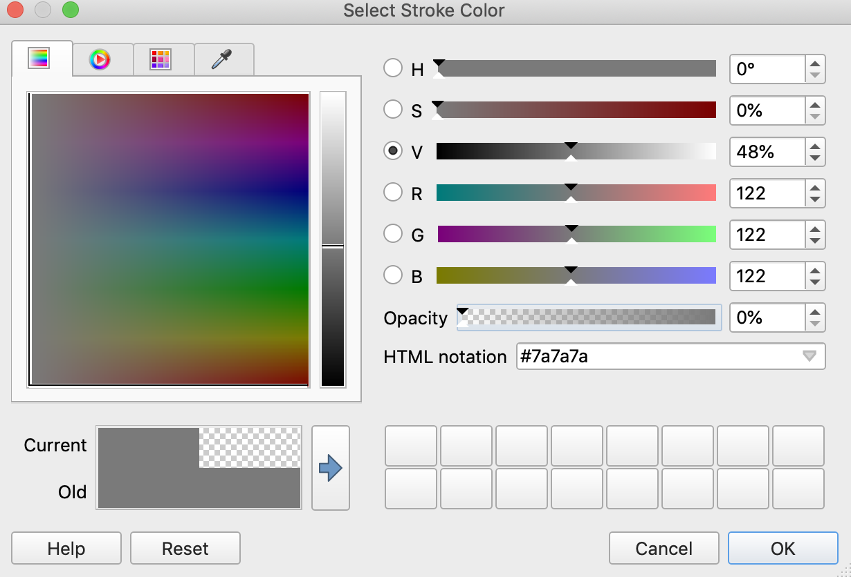 the **Symbol** menu.

Following the same steps as before, change the country symbols to a **Fill** color of 20% gray (**80% V**).

Open the Stroke color menu and enter **0%** for the **Opacity** value (making the stroke invisible).

Click **OK** to apply all your changes.

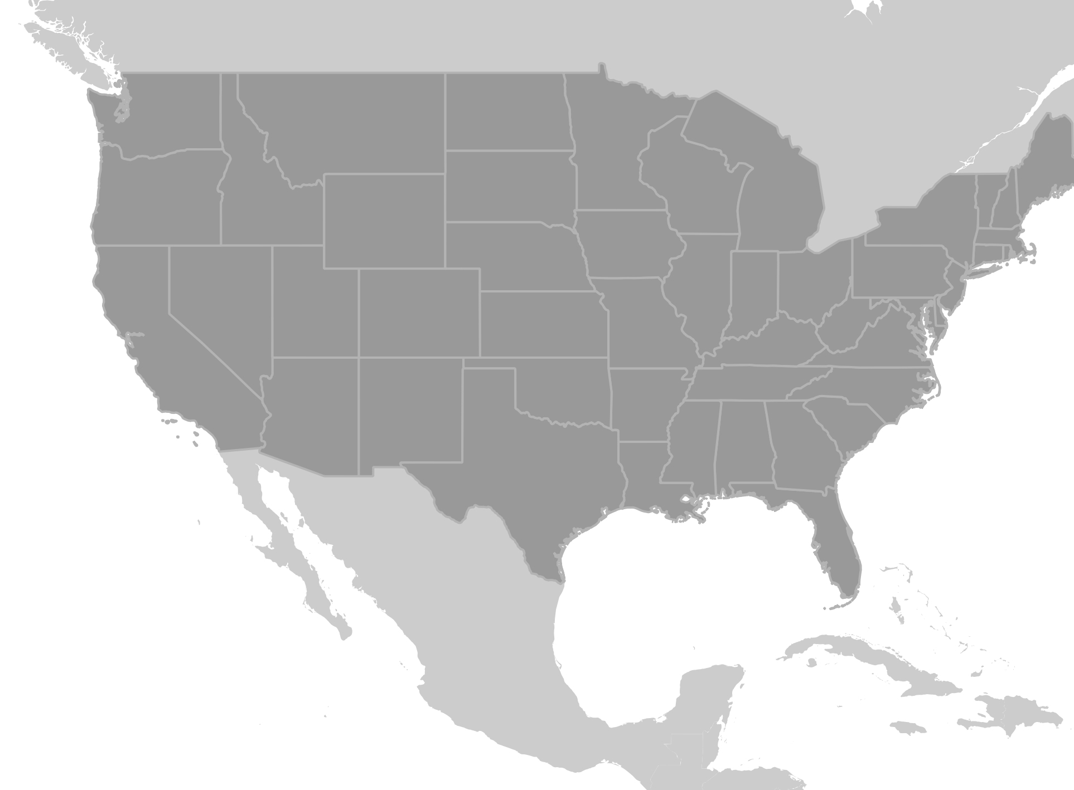

Full white and full black often sit at the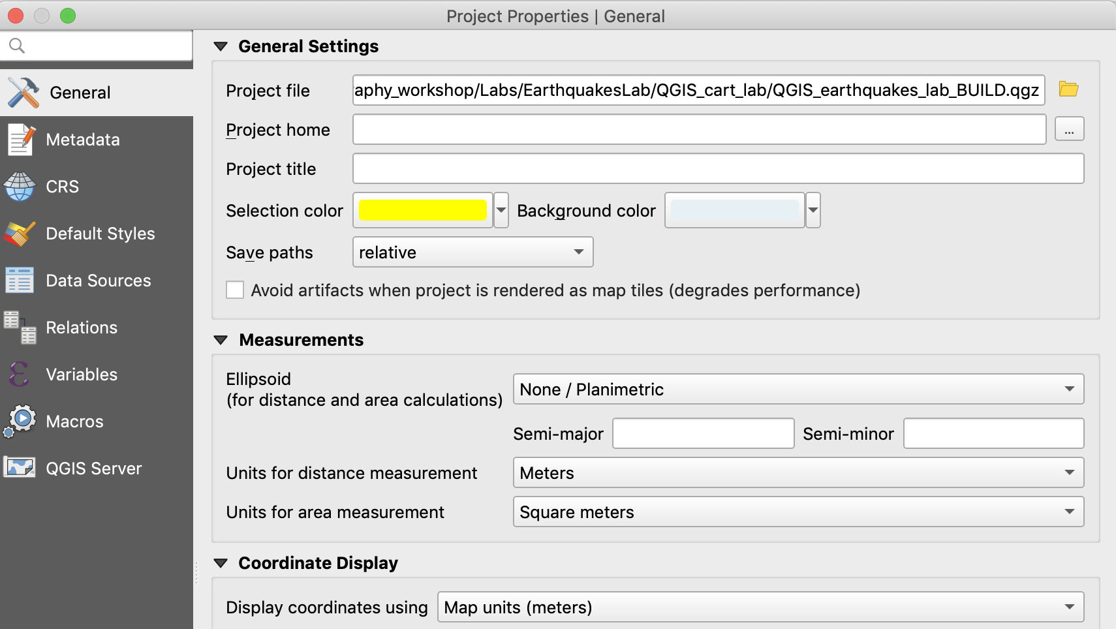 top of the visual hierarchy which is why we are using grayscale for the base map style. But removing the web basemaps has left our oceans full white and it’s a little distracting. We can set a fake ocean color by selecting a new background color for our project.

Under the **Project** menu in the top menu bar, select **Properties**.

Go to the **General** menu.

Find **Background color** and click the color bar.

Set the HSV sliders to 200*H, 5%S S, and 96% V.

Click **OK** twice to apply your changes.

The subtle use of color here separates the land from the water in our basemap, without pulling attention away from our data.

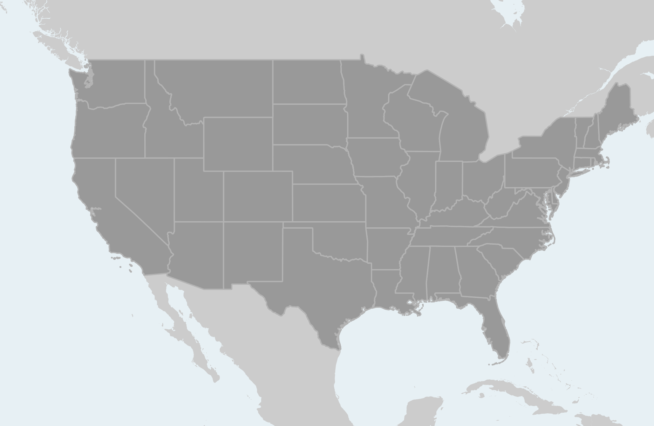

With less color and detail in the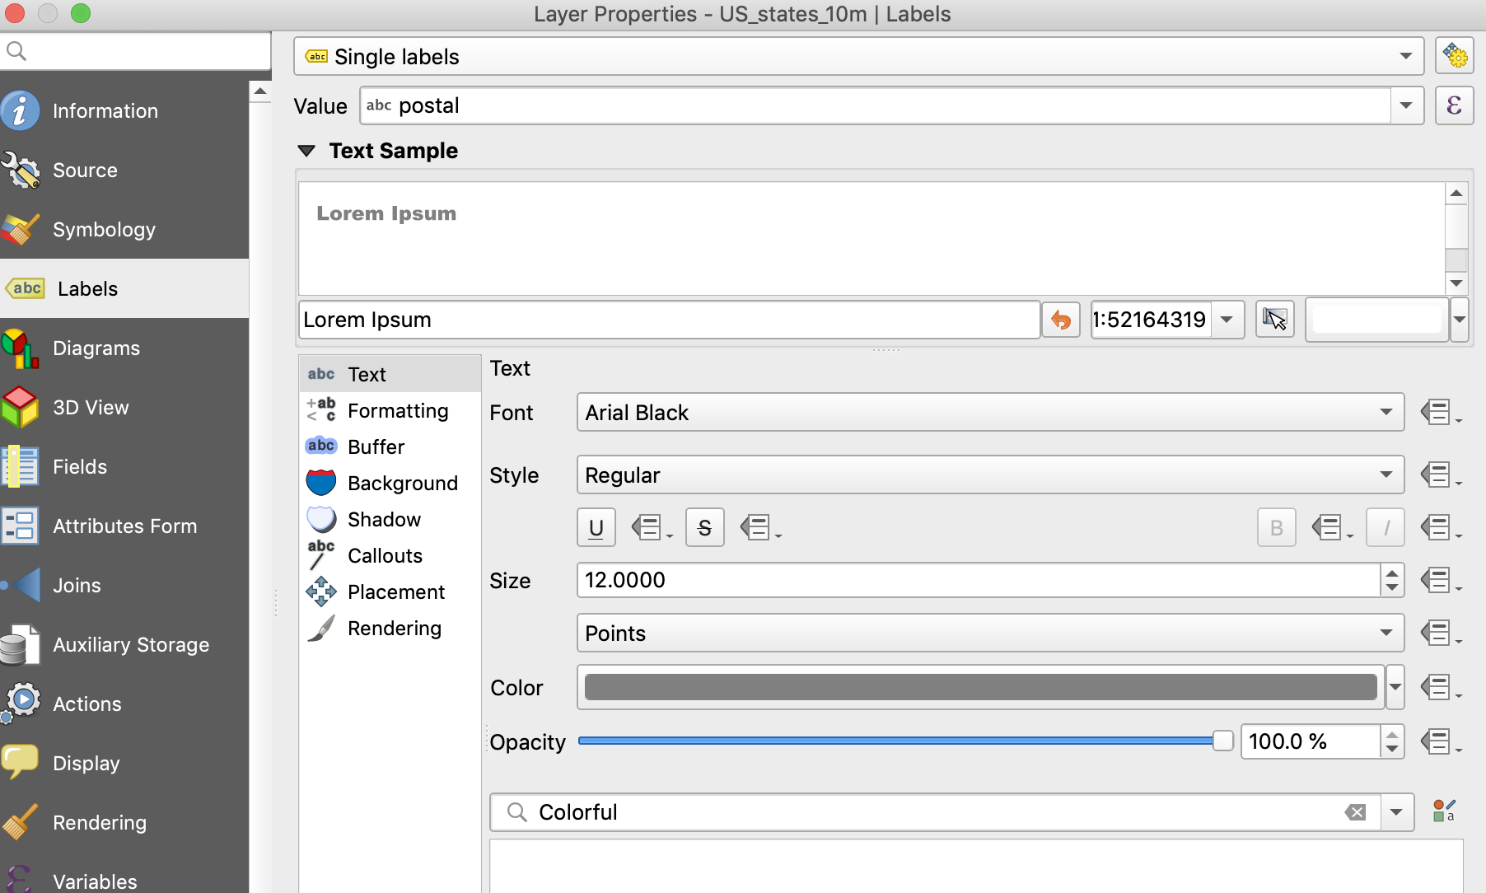 basemap we now have room to add back some detail in the form of state labels:

Double click the **US_states_10m** layer to open its **Properties** and go to the **Labels** menu.

Select **Single labels** from the drop down.

Change the **Value** field to **Postal** (for 2 digit postal abbreviations).

Change **Font** to **Arial Black**, set the **Size** to **12** Points, and change the color to a dark gray.

Click **Apply** to see your changes.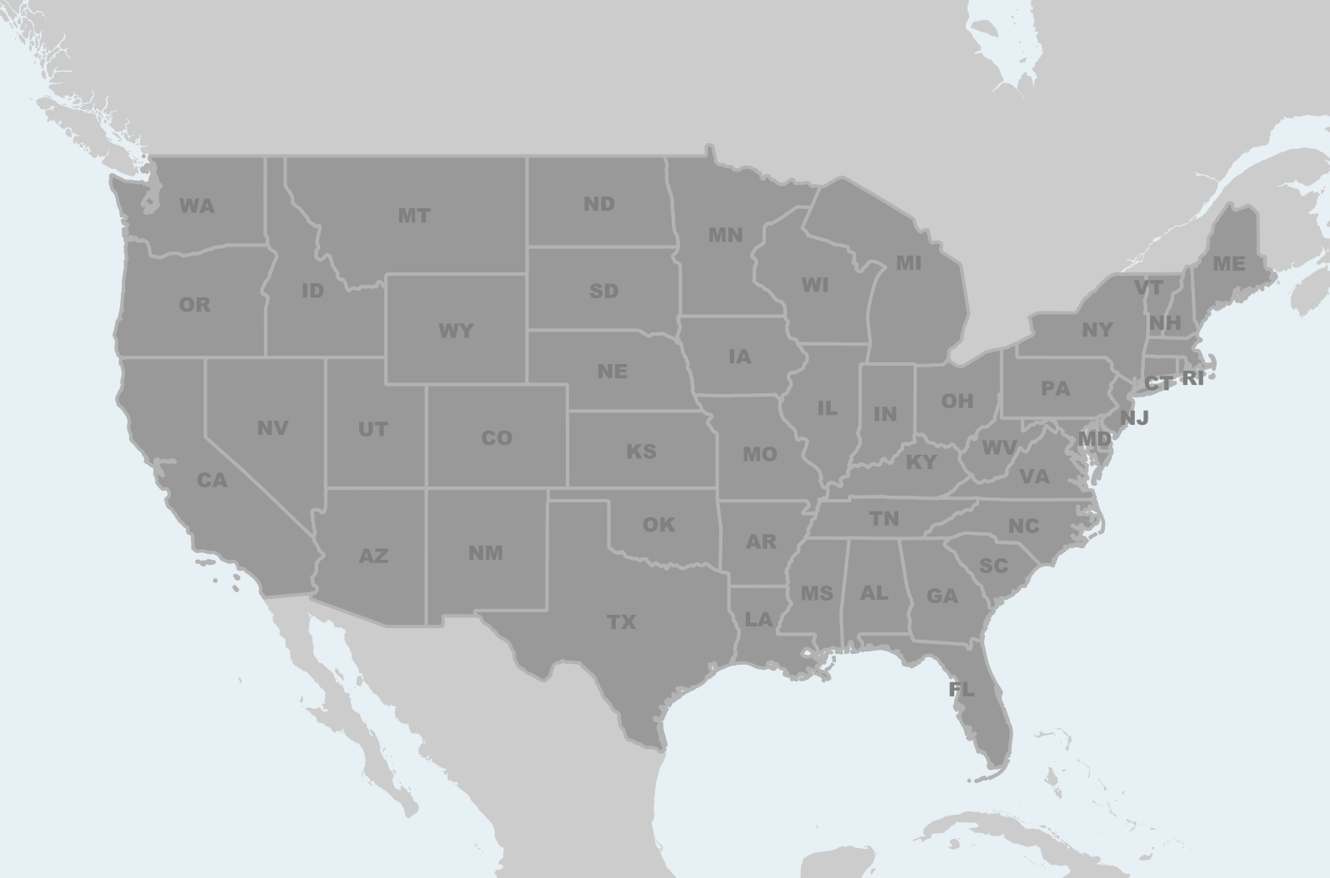

The final step in setting up a great custom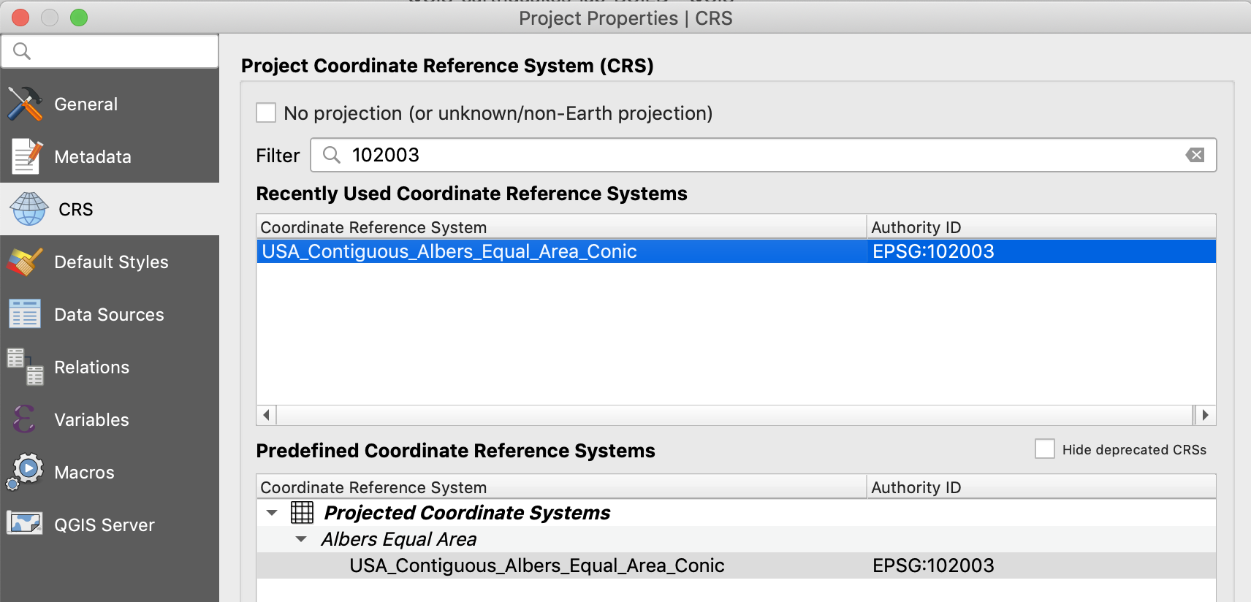 basemap is selecting a more appropriate map projection. Our current map is in the World Mercator projection (same as the web basemaps). It is an equirectangular projection that distorts both area and shape, elongating our polygons in the north - south direction.

Open the **Project > Properties** menu again.

Enter **102003** into the **Filter** search bar (the EPSG code for the **USA_Contiguous_Albers_Equal_Area_Conic** projection).

Select **USA_Contiguous_Albers_Equal_Area_Conic** from the results and select OK.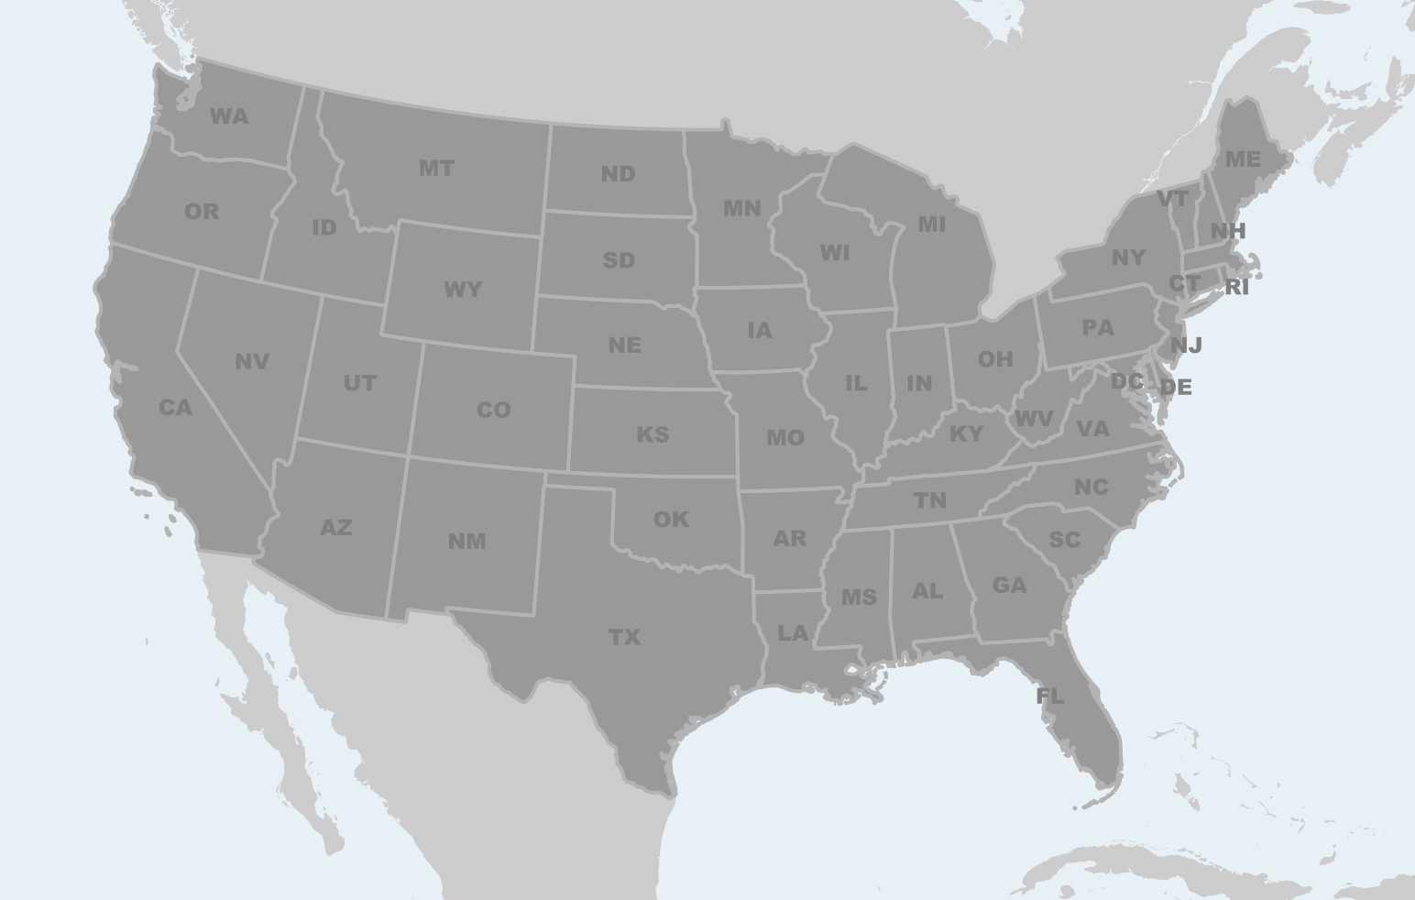

The map display will update to the new coordinate system, which is conic and makes our map both equal area and gives it a more pleasing shape with nicely curved lines of latitude (note the change along the US Canada border).

With that change we’ve gone from a flat VH using standard web base maps and default symbols to a custom basemap of our own design. And along the way we improved the VH, effectively separating the point data in our map from its context or background. Our next step will be to establish a meaningful symbology for reading the data itself.

Visual Variables.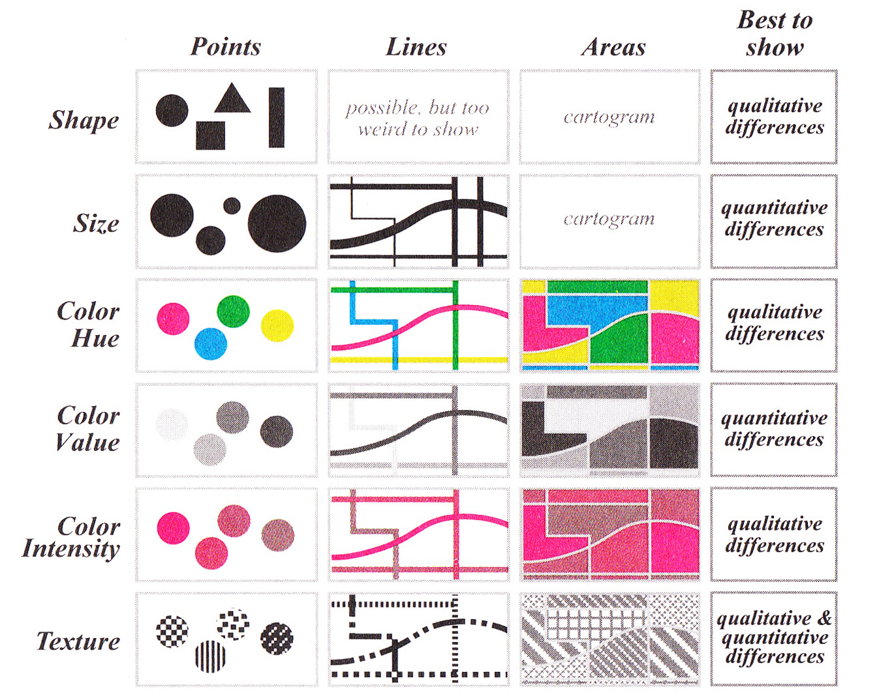

The point symbols in our map represent earthquakes for the year 2016 and contain attributes for magnitude (among other things). Right now they appear as simple point markers, but we can vary their shape, size or color to differentiate them based on class or values. When setting up a symbol style for map data it’s important to keep the Visual Variables in mind and use the appropriate variable for the kind of data you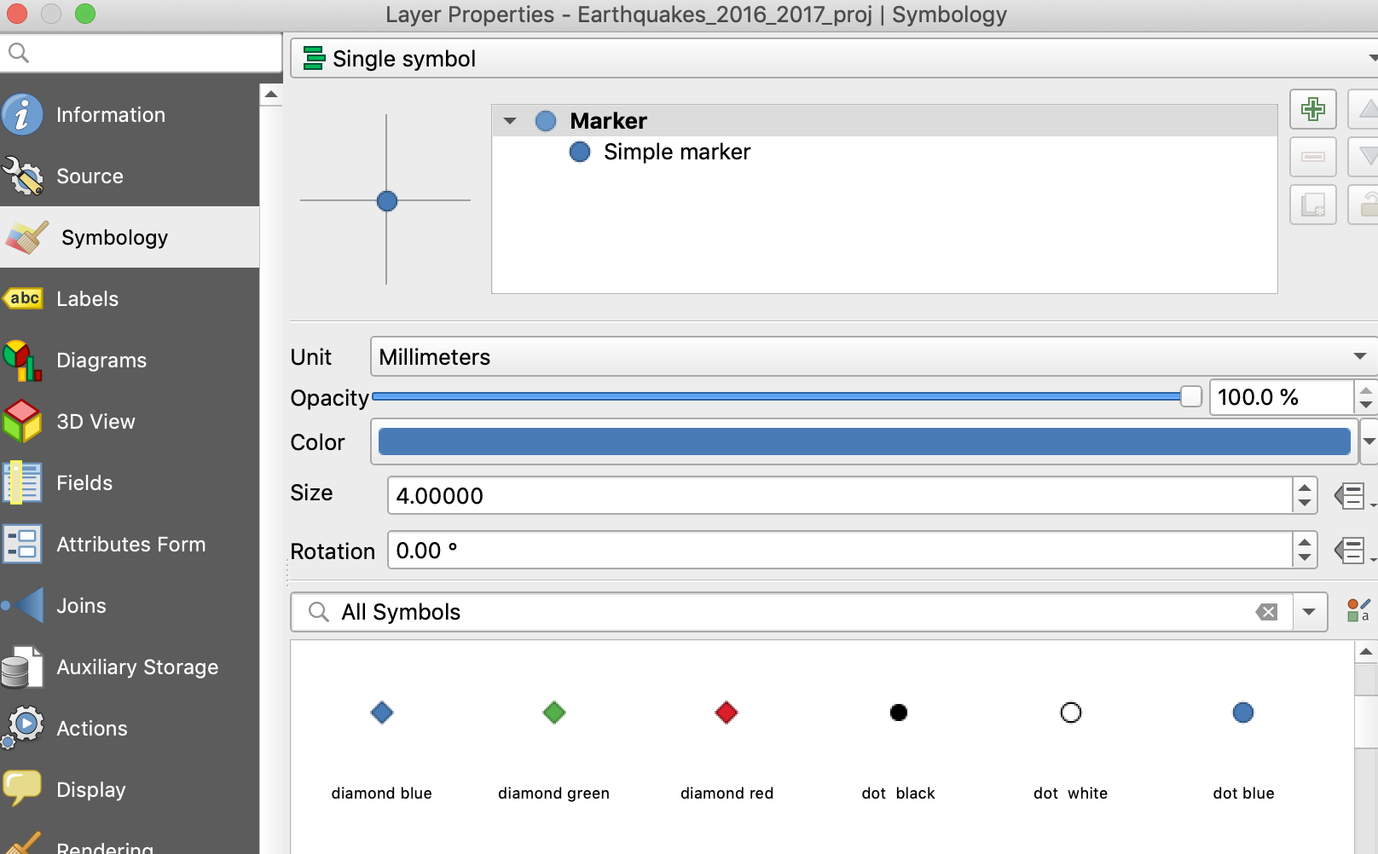 have (qualitative vs quantitative).

Open the layer **Properties** for the **Earthquakes_2016_2017 layer**.

In the **Symbology** menu for **Single Symbol** Scroll down to the All Symbols palette and choose the small blue dot.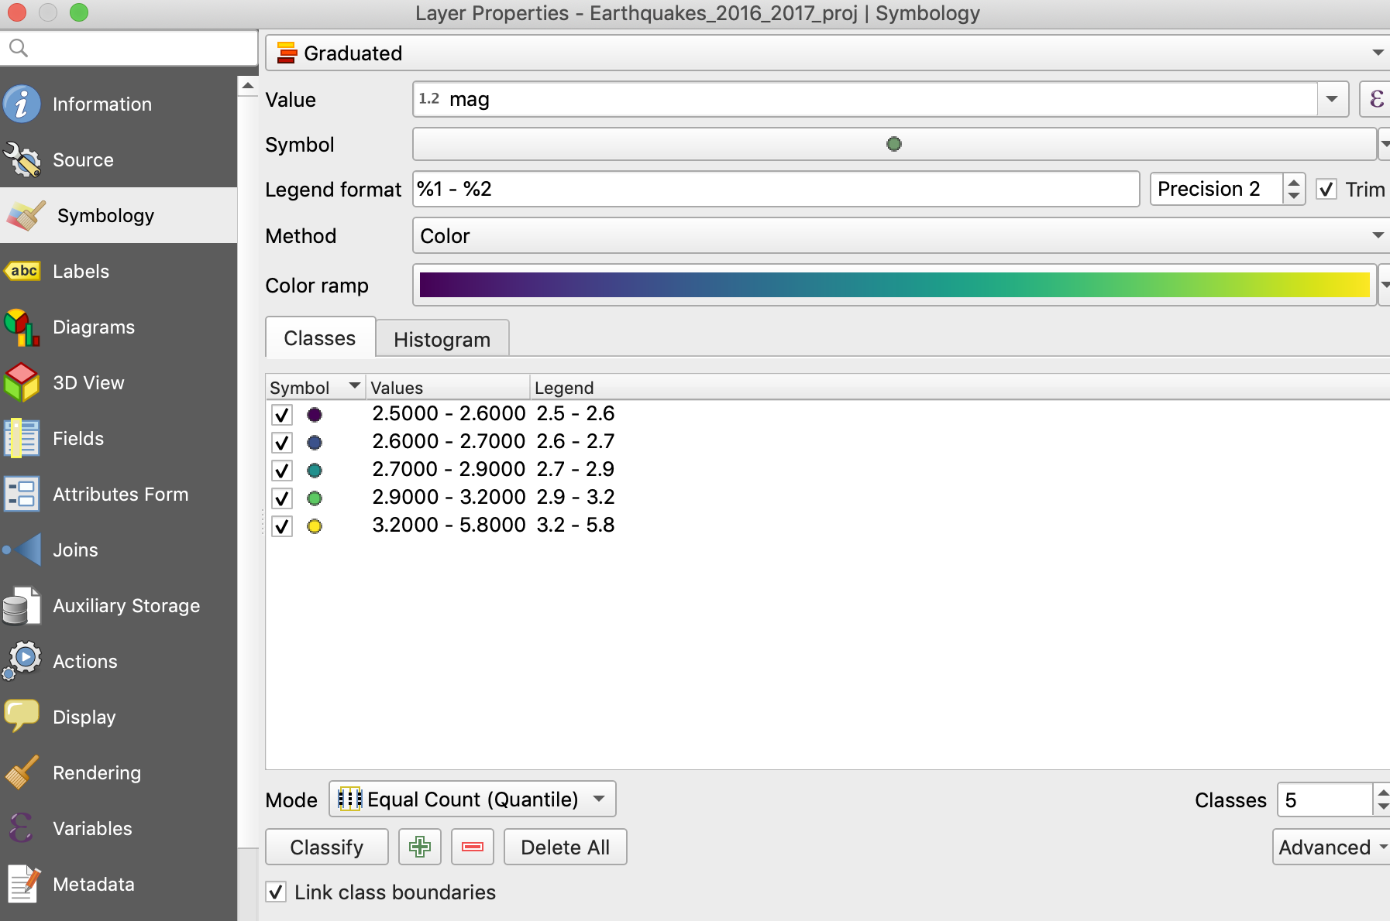

Click **Apply**.

The point symbols will update to the new style. These are still point locations only, no data vales are being expressed.

In the **Symbology** menu change symbol type for **Single symbol** to **Graduated.**

Set the **Value** field to the **mag** attribute.

Set the **Color ramp** to **Viridis** (or pick your own).

In the **Mode** drop down choose **Equal Count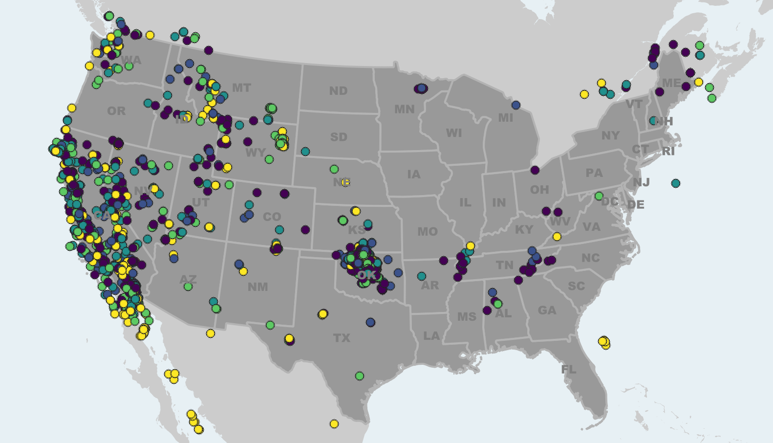 (Quantile)** then hit the Classify button to add your values.

Press **Apply** to see the changes.

Note: if your map symbols are too small use the **Symbol** button on the Graduated symbology menu to set a new point size.

This is ok for seeing values in our symbols, but there’s so much data here we can’t see the overall density of observations. QGIS has some other options under the symbol menu for dealing with dense point symbols like **Point Cluster** and **Heat Map**. Feel free to explore. We’ll use QGISs built in layer blending tools to help us make a semi transparent point aggregation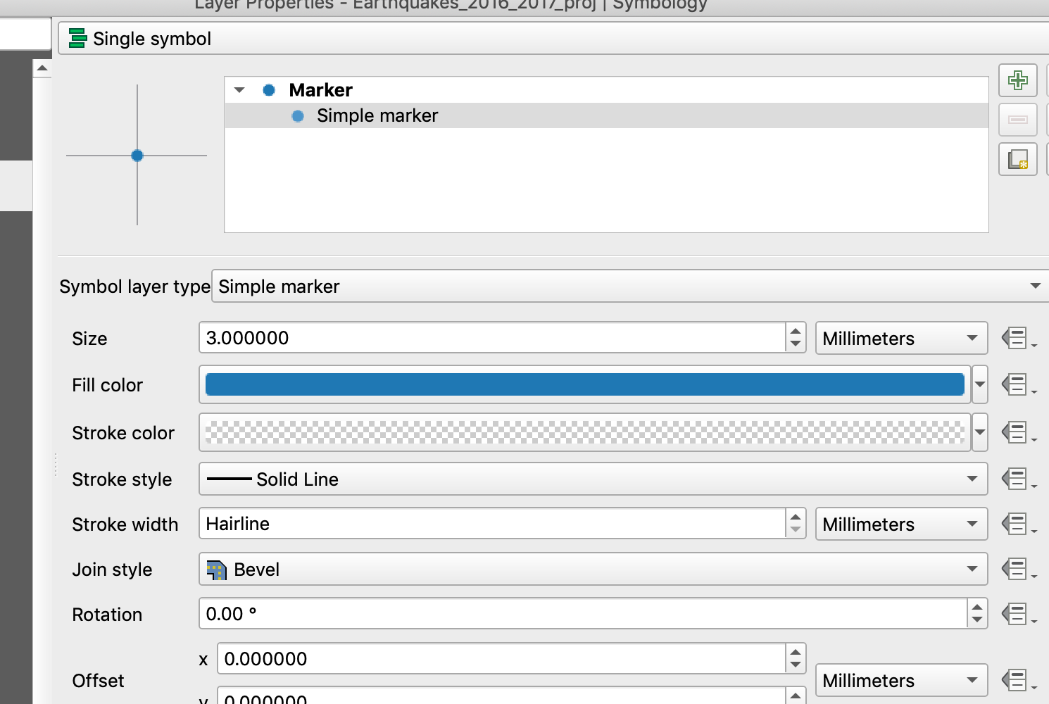 map instead.

If you closed the **Symbology** menu for the earthquake layer, open it again now.

Change back to a **Single symbol** style.

Click on **Simple marker** then set the **Fill** color to blue.

Set the **Stroke Color** to **0%** **Opacity.**

Click open the **Layer Rendering** options.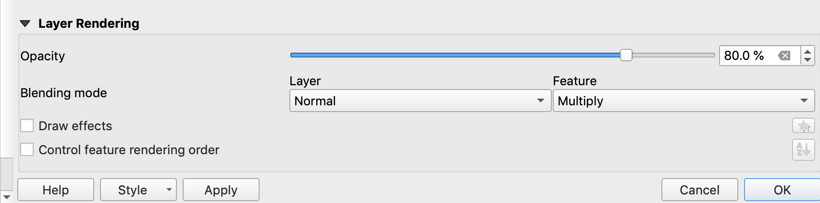

Under **Blending** mode, set **Feature** blending to **Multiply**.

Set **Opacity** to **80%**, hit **OK**.

The effect you get will one of aggregation, with stacked points creating an additive darkening effect. It’s not a quantitative method, but does a good job of highlighting dense areas on overlapping data.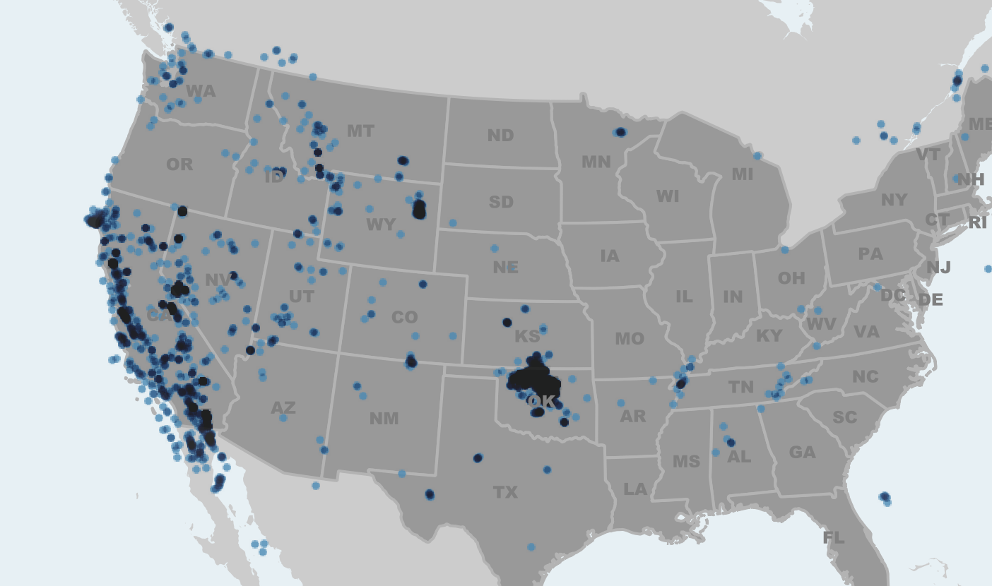

Click the check box next to the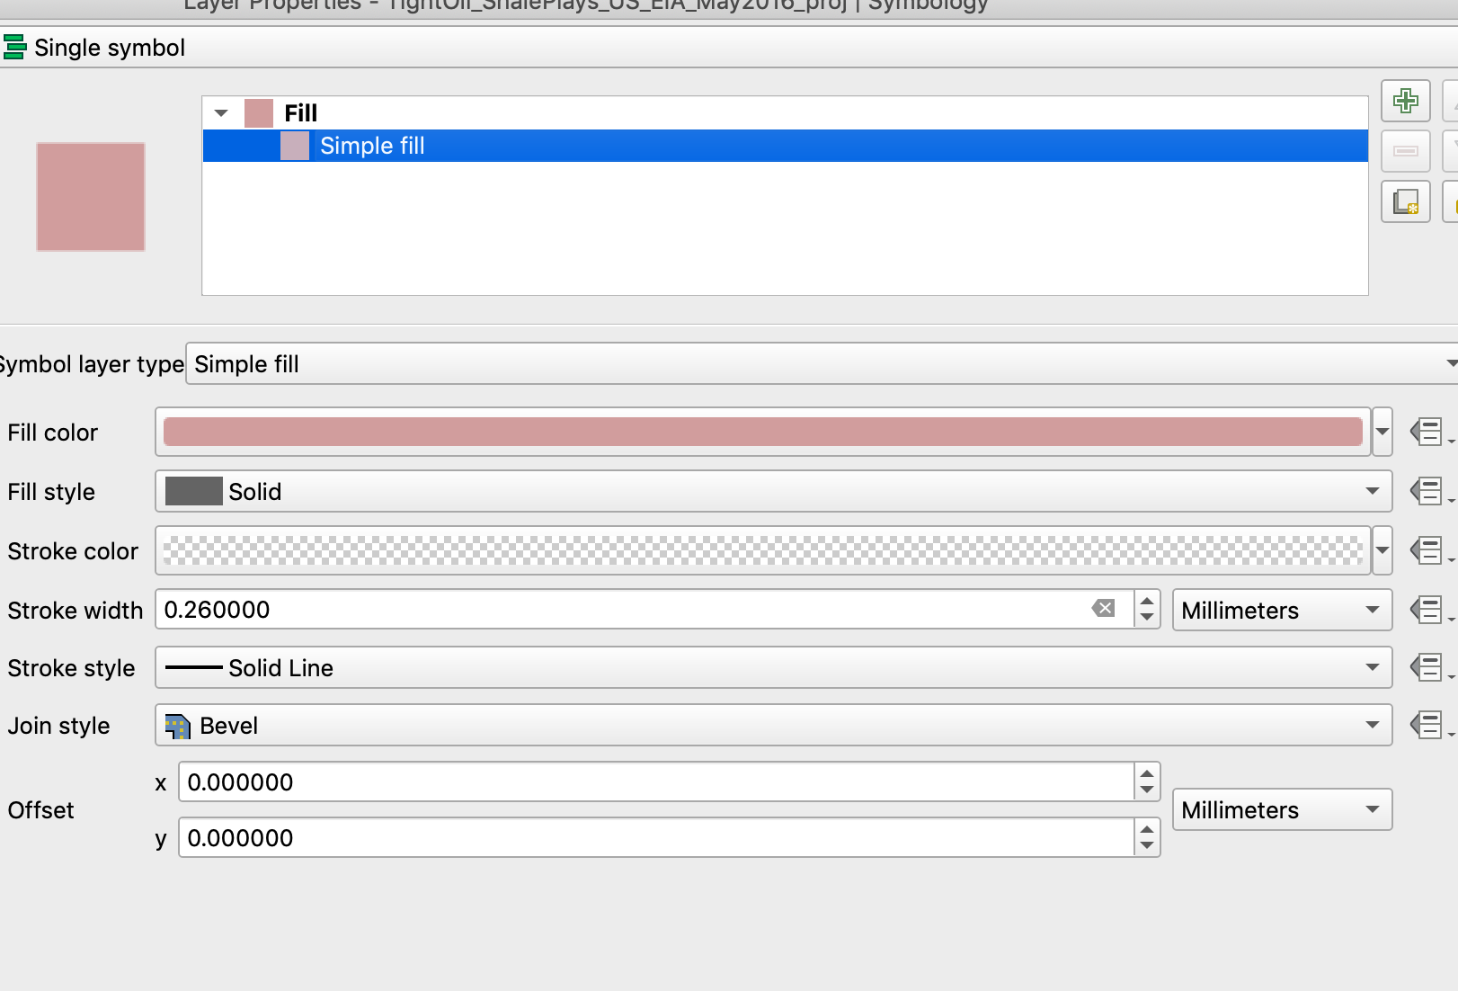 **Tight_Oil_Shale** layer to turn it on in the map.

Using the **Symbology** menu give these polygons for oil deposits a med/dark red fill with no outline.

Under the **Layer Rending** options, set both **Layer** and **Feature** to **Multiply**.

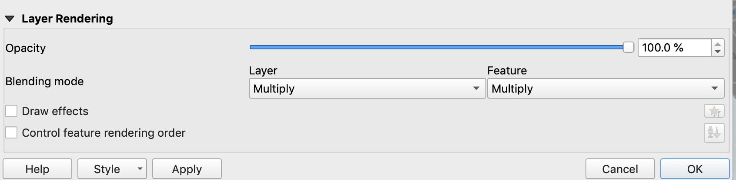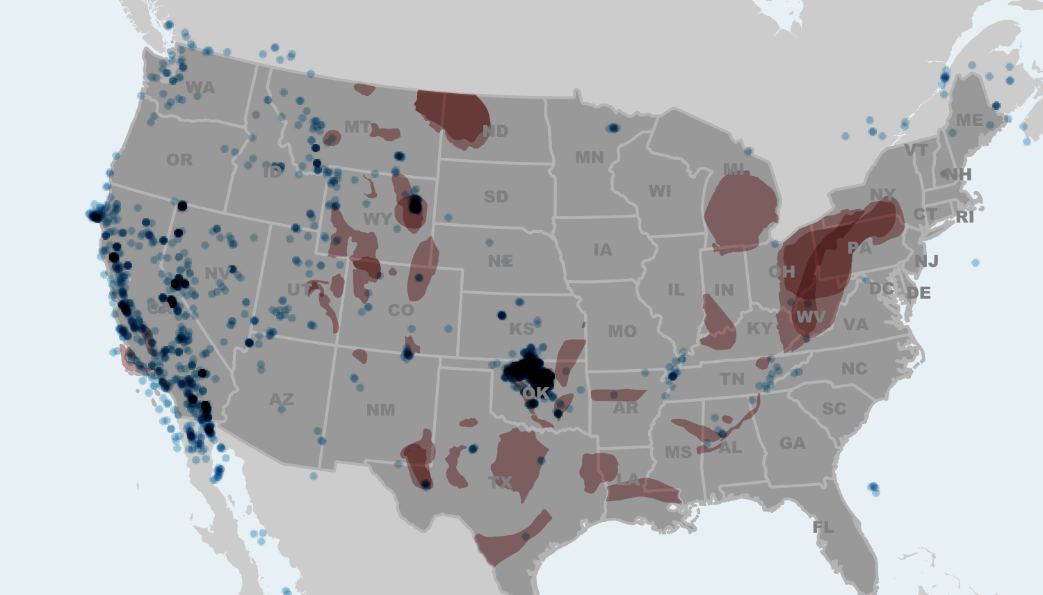

Make the map already.

While you can export the map now as it appears in the main map window, for published maps its best to switch into a layout view so we can set up specific page sizes and insert the various elements that help a map work, like titles and legends.

QGIS uses a Layout Manager to handle multiple Print Layouts from a single map project.

From the main menu bar, select the **New Print Layout** button.

Give your new map layout a name (e.g. My Map)

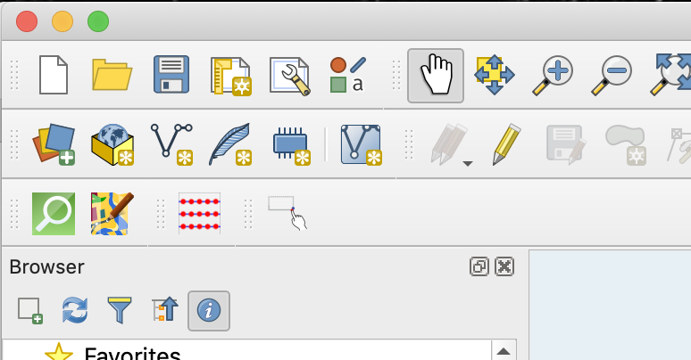

The initial view is of an empty sheet of paper to which we can embed our map view and other various map elements like legends, scale bars etc.

To set a specific page size for your layout you can right click on the page and select **Page Properties**. In the **Items Properties** menu to right of your layout will be options for setting different standard or custom page sizes. We’ll leave ours set to A4 for now.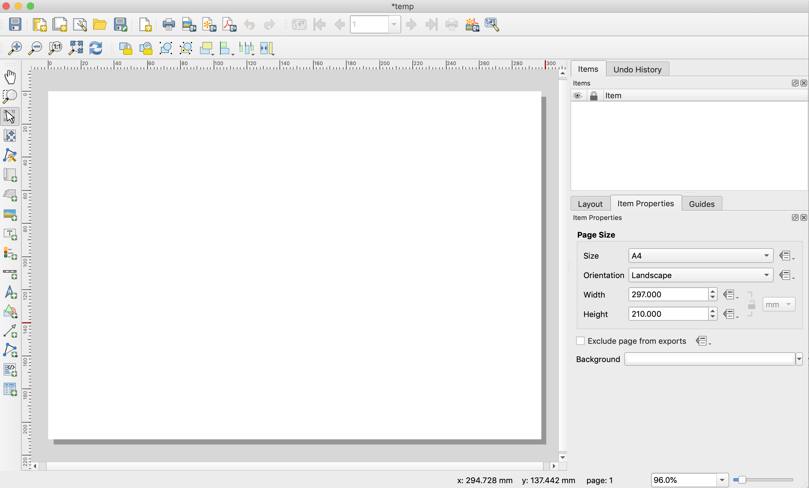

Select the **New Map Layout** tool from the layout tool sidebar.

Click in the empty print layout page to drag a box for your map (or simply click in the layout and enter a specific map layout dimension).

Notice that as you add the map frame to your layout a new entry appears in the **Item** menu to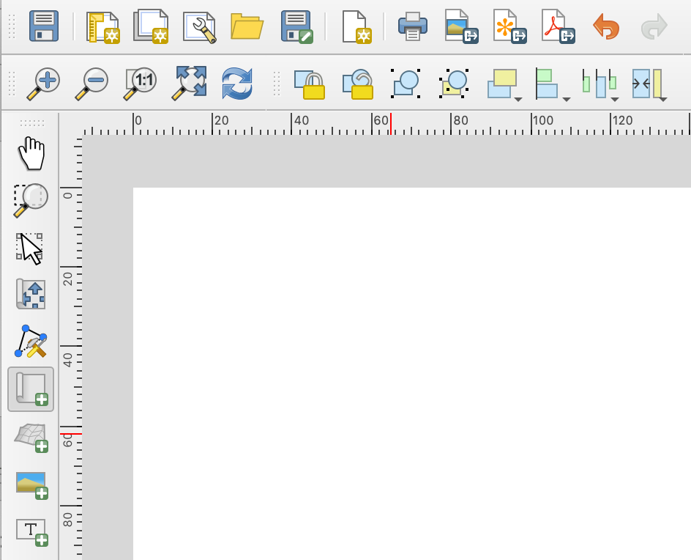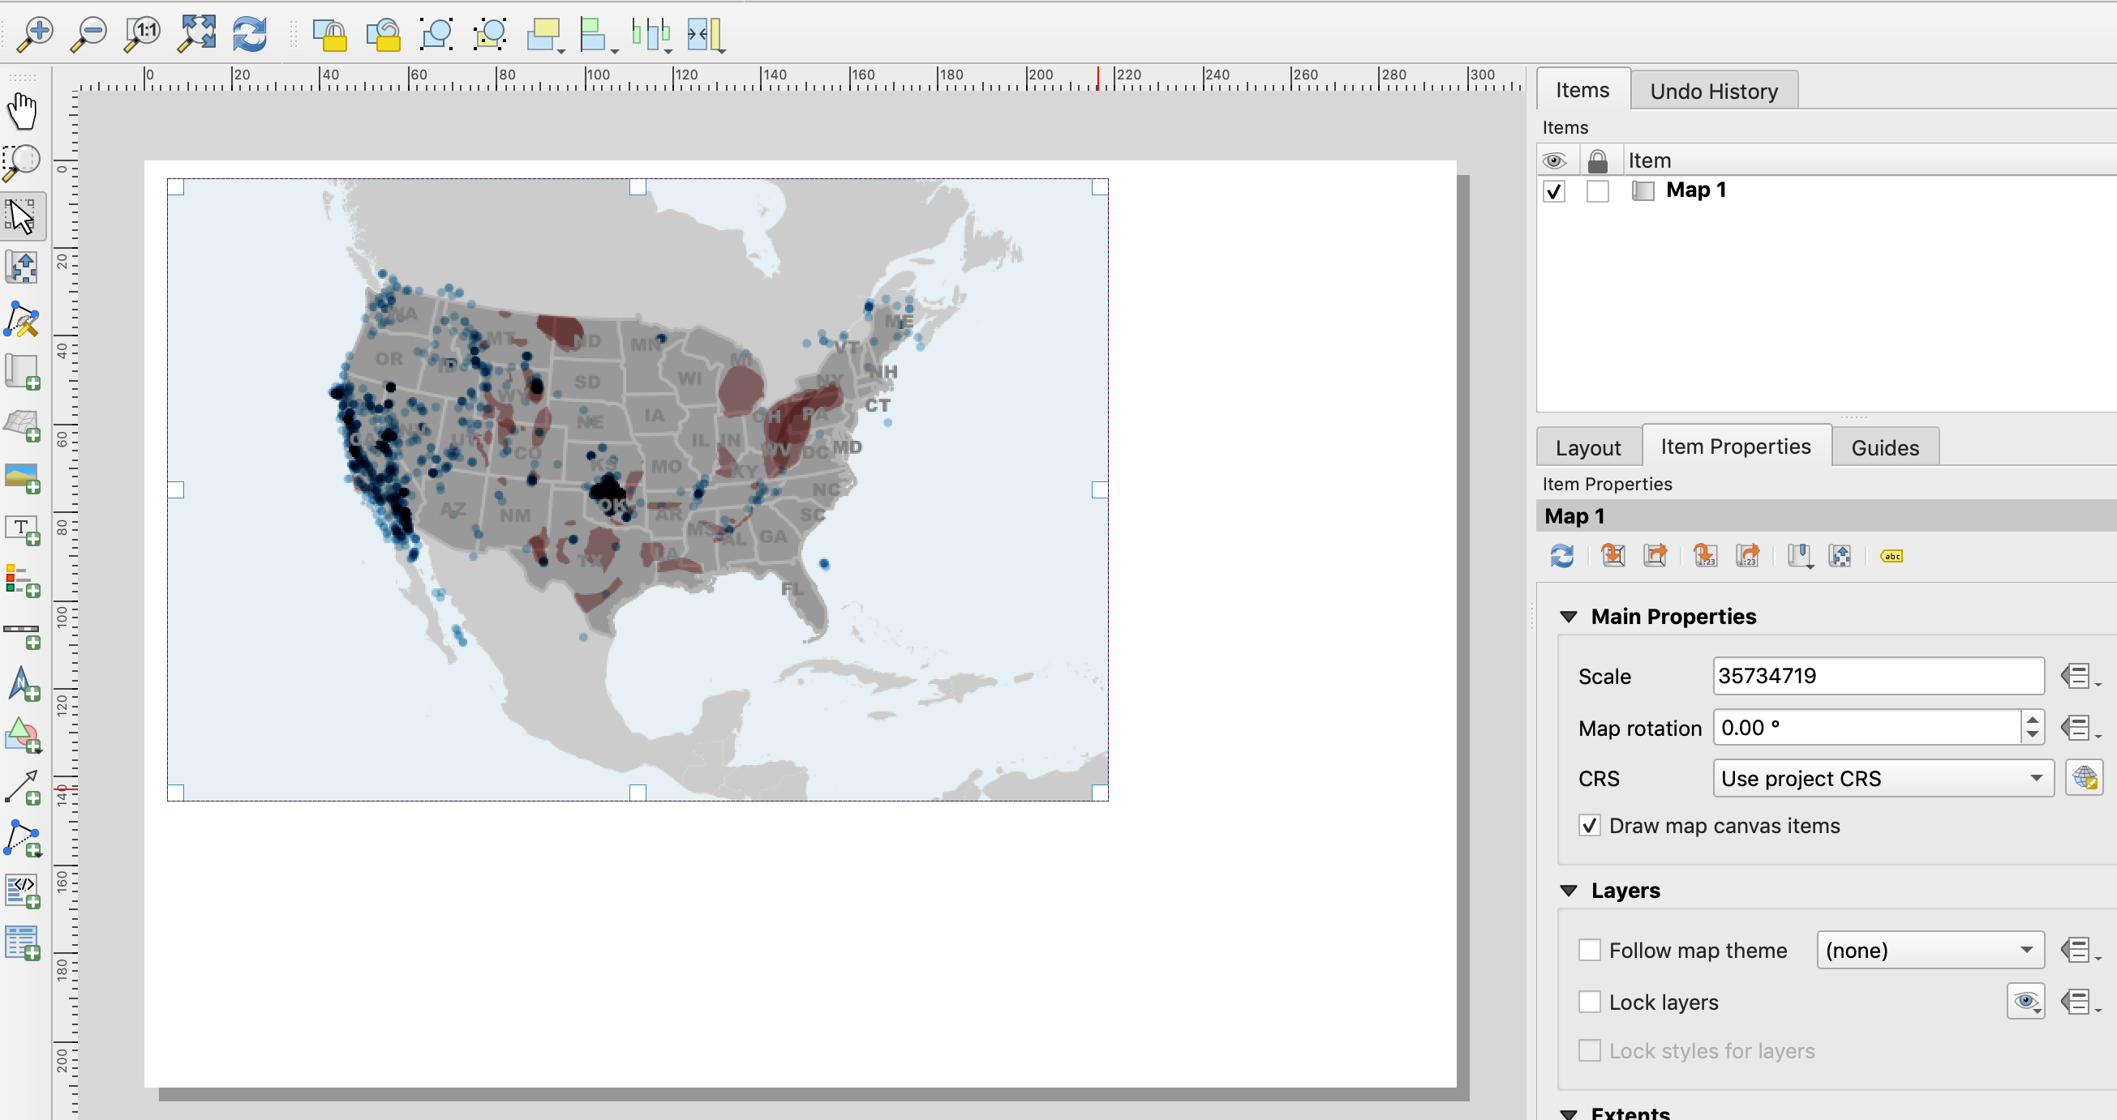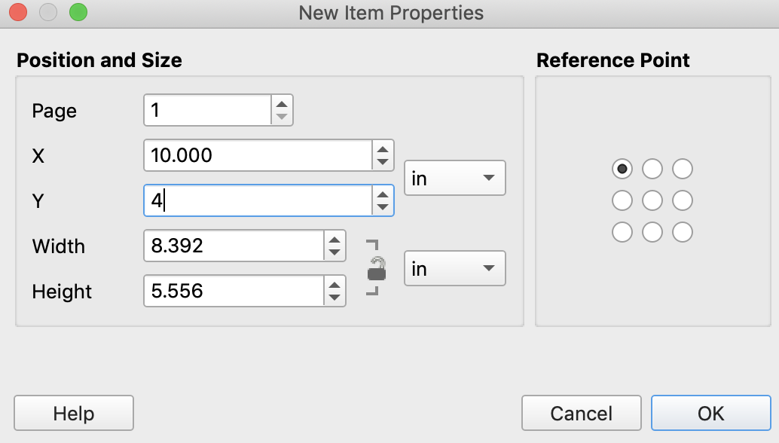 the right of your map.

This **Items** menu is where you’ll access all of the settings and customizations for each element in your map layout.

The menu is contextual and will change to match whatever item you have selected in the layout.

Use the **Select/Move** tool to select different map items.

Select your map with the **Select/Move Item** tool and drag the edges of the frame out to meet the edges of the layout page.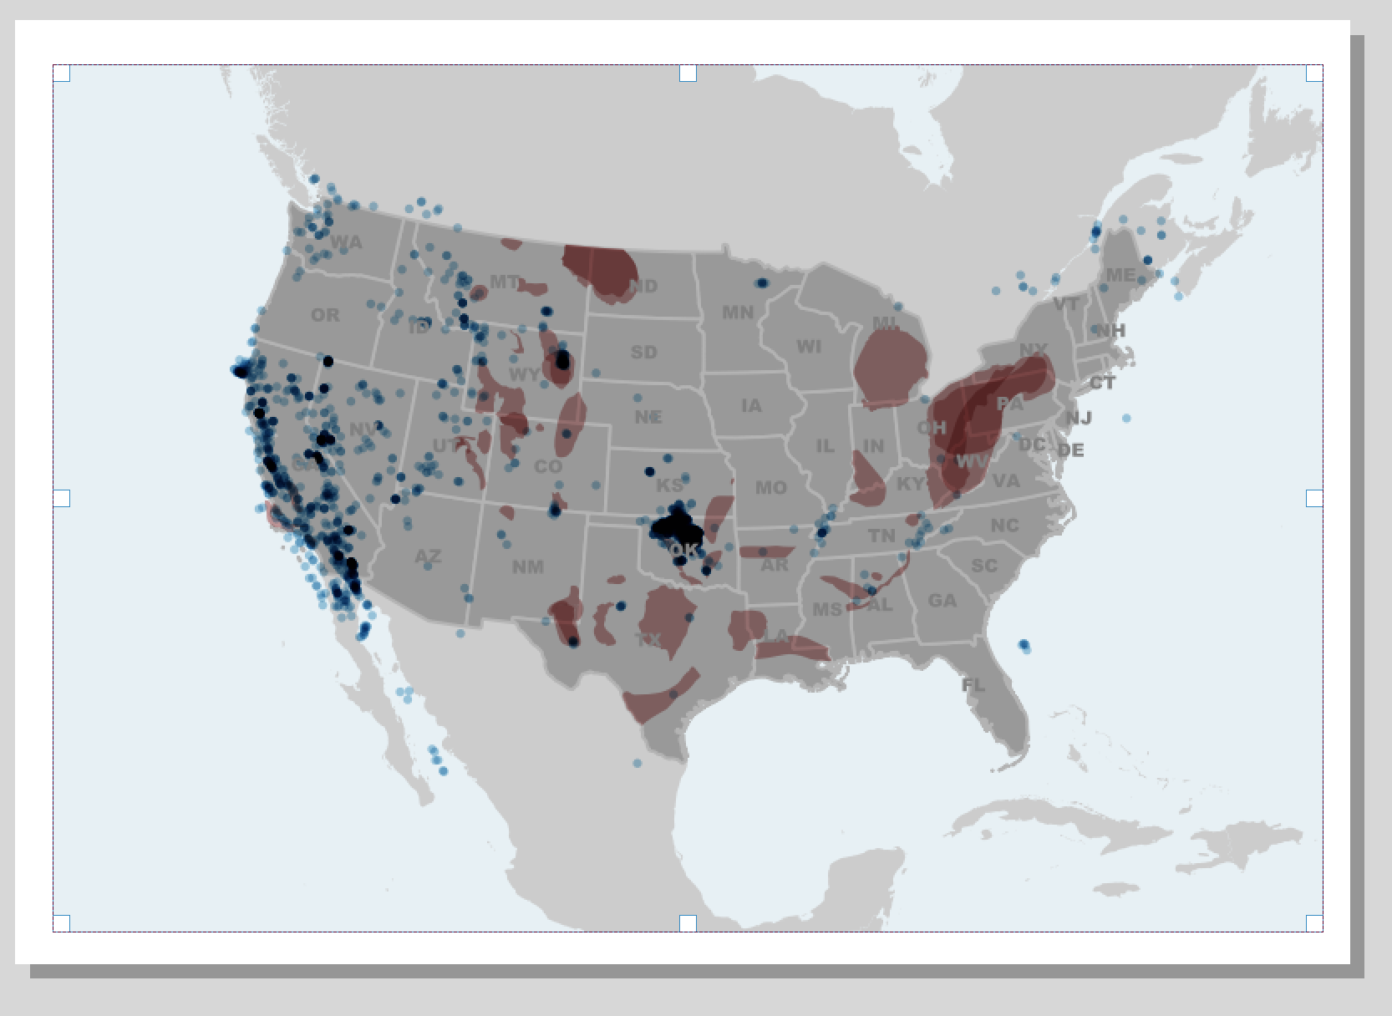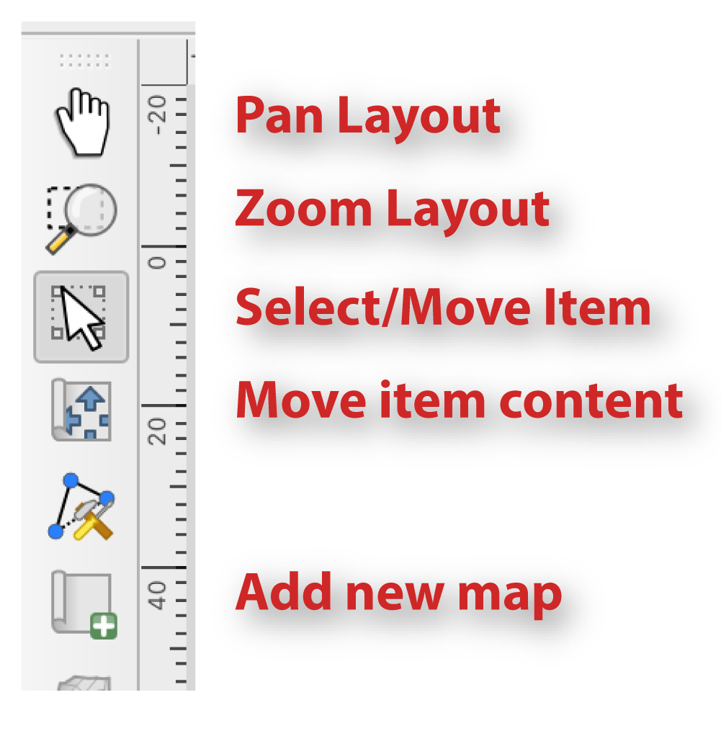

Use the **Add Label** tool to drag a title box near the top of the map.

In the **Item Properties** menu to the right, enter the text for your title: “**Earthquakes 2016**”

Use the Appearance menu to set your font to something large like **Arial Black,** and a 24 point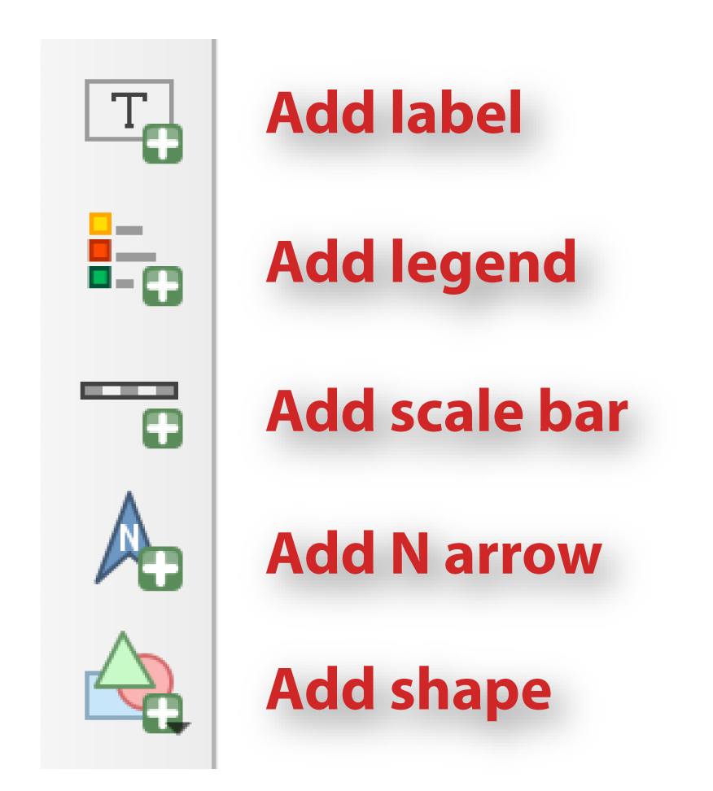 size.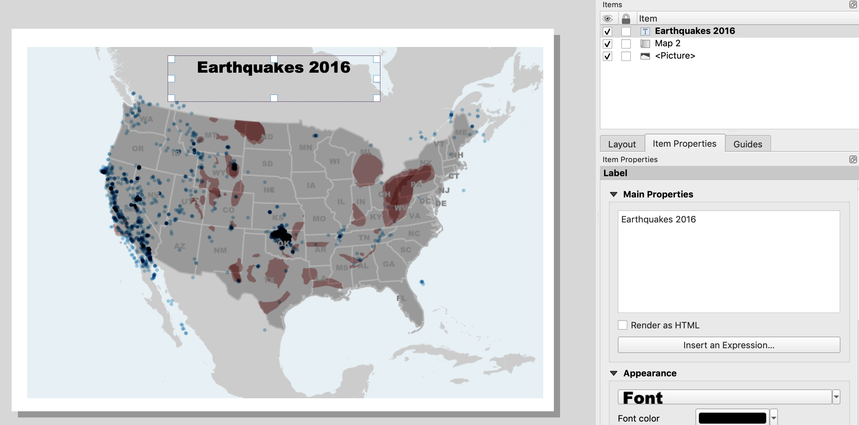

Use the **Add Legend** tool to drag a new legend box in the lower left corner of the map.

In the **Legend Item Properties** to the bright, scroll down until you see the check box for **Background** and uncheck it if necessary.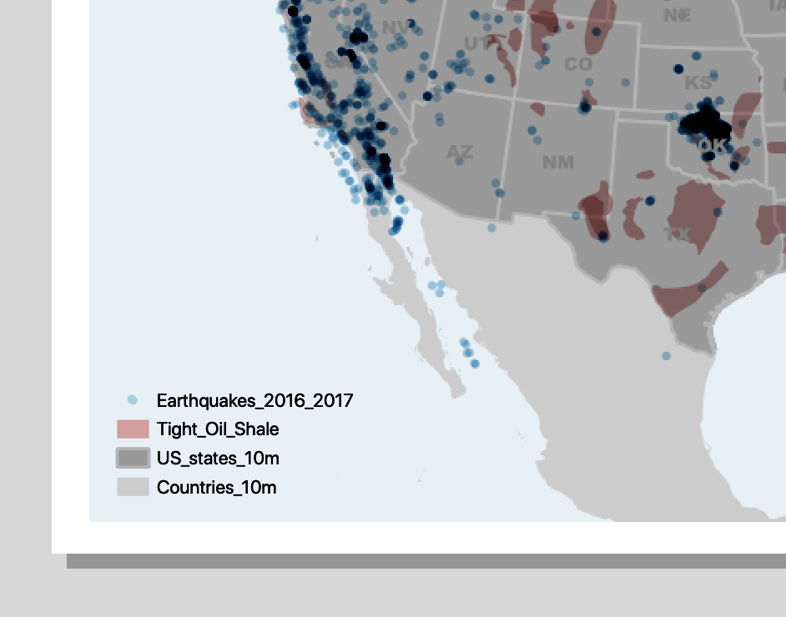

Note: you can remove items form the legend in the **Items Properties > Legend Items** menu.

Use the **Add Scale Bar** tool to drag a small scale bar into the lower right corner of the map.

Under the Scale Bar **Item Properties** menu, open **Main Properties** and change the **Style** to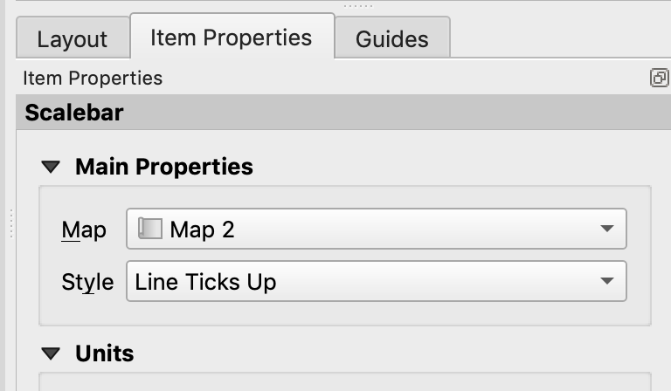 **Line Ticks Up**.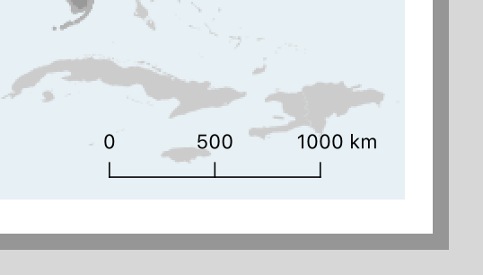

Each of these items in the map layout have a number of options and customization controls that you can find under the Item Properties for each item. I encourage you to play around with them and get to know how you can customize our map and its features. For now we’ll move on to the final step in making a map and that’s exporting it!

Click on the **Export as Image** button from the top menu on the Layout window..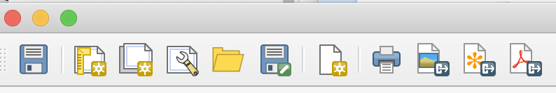

Change the export type to **jpg** or **tif**.

In the **Export Options** menu that appears set the output **DPI to 300** and click **Save**.

Note: if you anticipate needing to use your exported m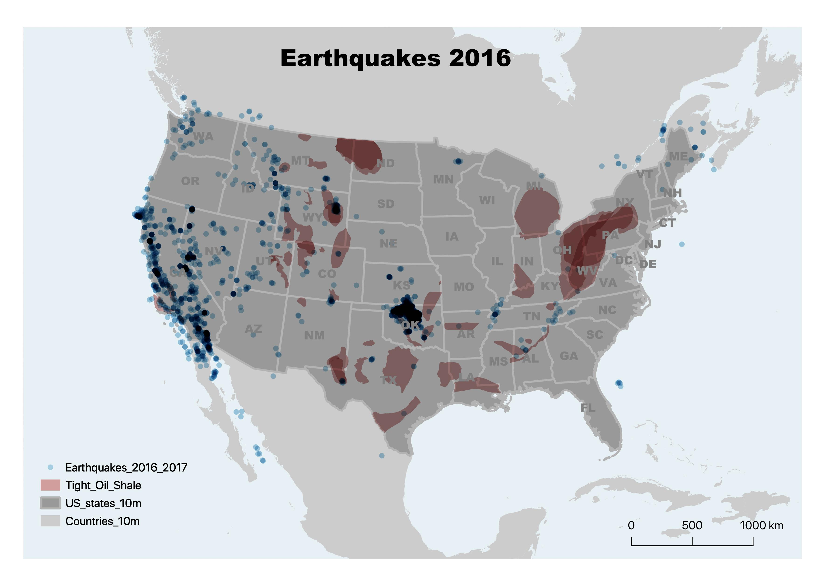ap in another GIS project you can select the **Generate world file** option to geo reference your image as its saved.

Browse to your saved map location and double click to open it in a photo viewer.

Pat your self on the back, you’re now a cartographer!

Extra Stuff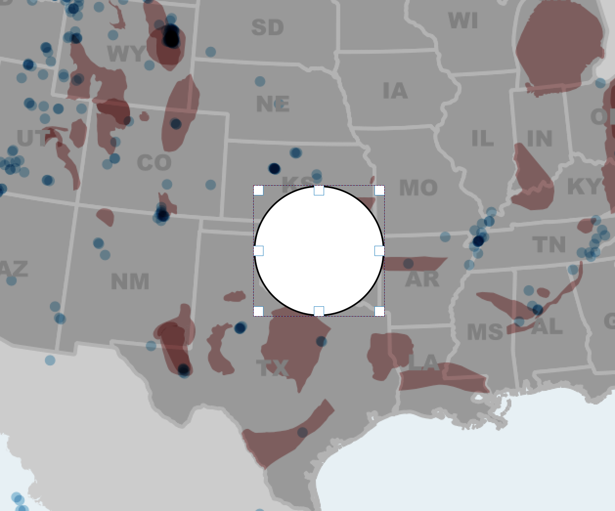

There’s always more you can do in cartography!

We can add call outs and text blocks to help annotate our map with the Add Shape and Add Label tools.

Click the **Add Shape** button and select **Add Ellipse**.

Click to drag a small circle over the cluster of earthquakes in Oklahoma.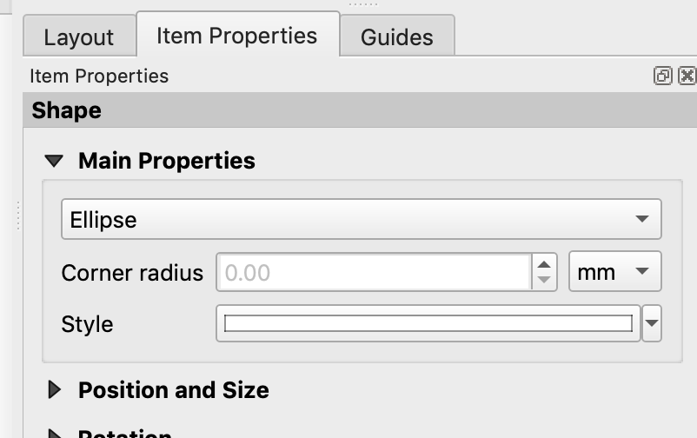

With the new shape active, go to the **Items Properties** window and click on **Style** under **Main Properties**.

Select **Simple Fill** in the menu.

Set **Fill Style** to **No Brush**.

Set **Stroke Color** to **white**.

Set **Stroke width** to .**6 mm**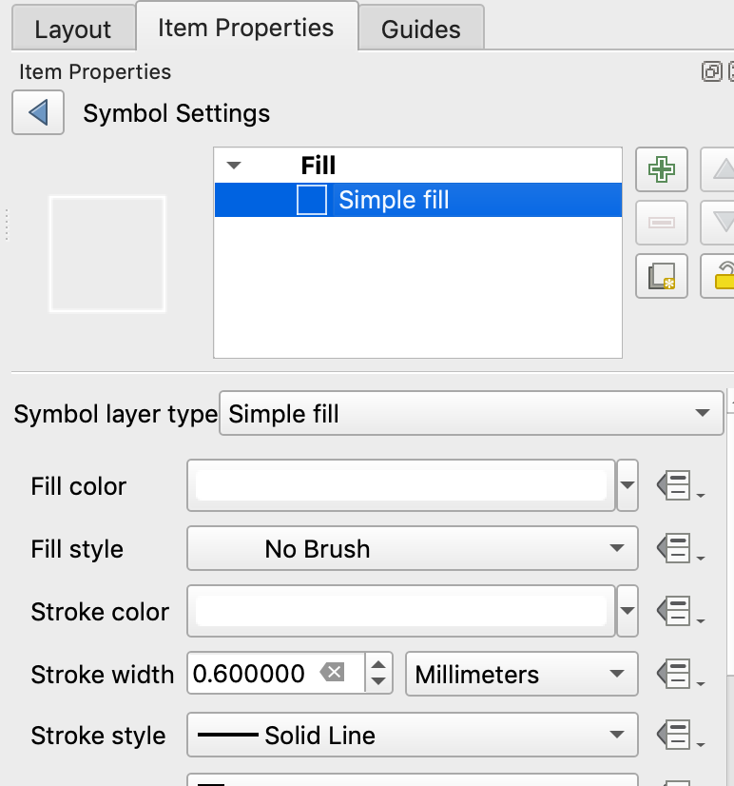

Next select the **Add Label** tool and drag a small rectangle to the right of the new circle.

Enter the text **Oklahoma earthquake swarms** in the **Item Properties > Main Properties** box.

In the Label **Appearance** menu change the font color to **White**.

Click on the **Font** button and enlarge the font size to about 14 our 18 points. You can also change the font style as desired.

Use the **Select/Move** tool to re size and re position your new label.

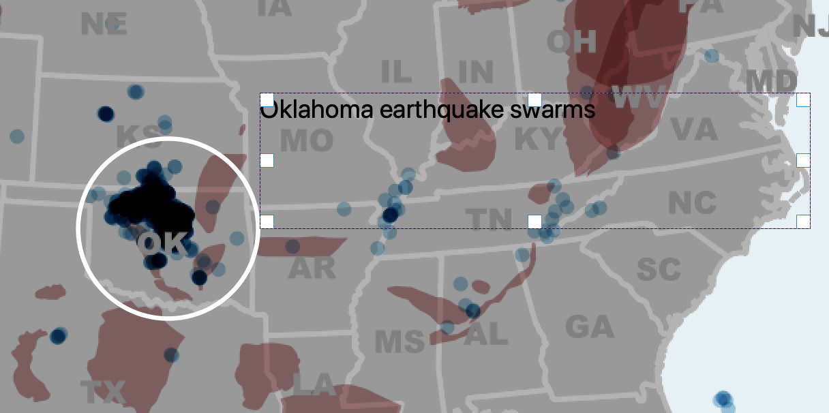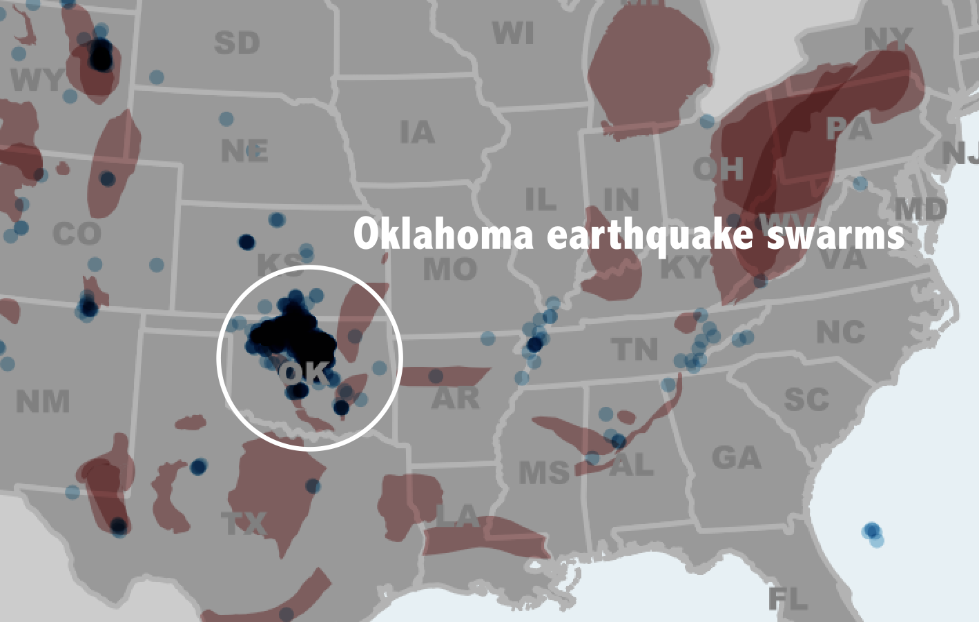

In the rare (but fun) case that you need to give your map a cool looking background for something like water or paper, you can do this by inserting a standard image as your background.

Select your map frame and go into the **Item Properties** menu.

Scroll down to the **Background** item and uncheck it. The background color should disappear.

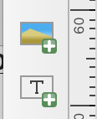

Select the **Add New Picture** tool from the layout menu on the left.

Drag a box to match the extent of your map frame.

In **Item Properties > Main Properties** click on the browse button for **Image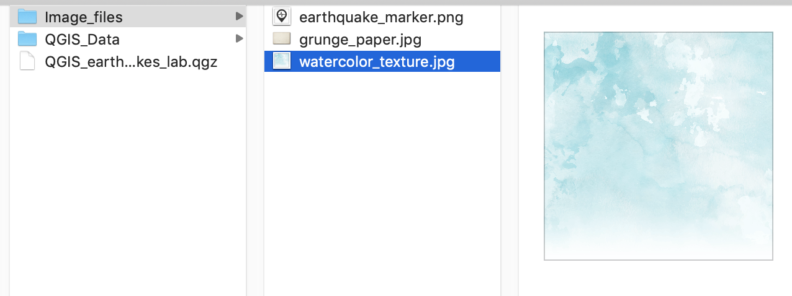 Source**.

Browse to the downloaded folder for this lab.

Go into the **Image_Files** folder and select **Water_Color_Texture.jpg**.

Under **Main Properties** set the **Resize Mode** to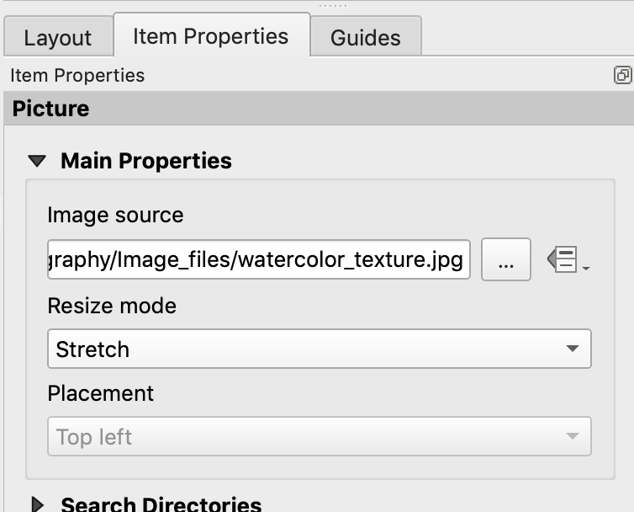 **Stretch**.

The image will initially appear on top of your map, we need to move it to the background.

Go up to the top menu bar in Print Composer and select the **Raise Selected Items** button.

Click on the **Send to Back** option.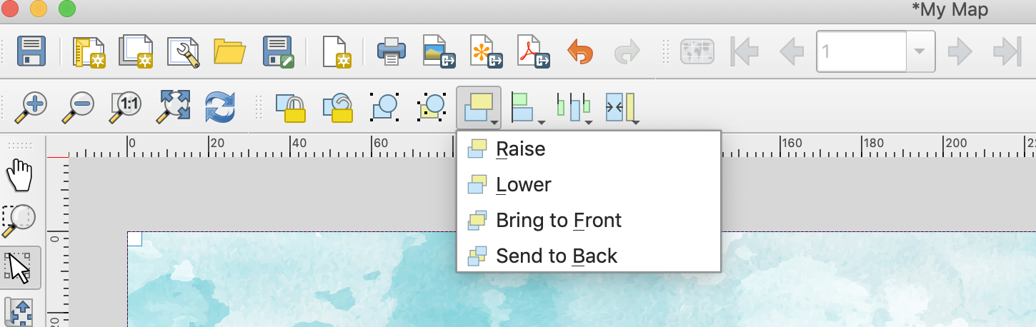

Sit back and marvel and what an awesome looking map you’ve made!

Hopefully by now you get the idea that there is A LOT you can do in QGIS to customize your maps to suit your projects and your tastes.

